Advanced Business Intelligence

and Analytics

INFS 5135

Analytic Plan

A2

|  |  |
| --- | --- |
| Student ID Number | Group Member Name |
| HERKY010 | Hernandez Silveira,Kellen Veridiane |
| HUYTY042 | Huynh,Trung Hieu |
| NIEYY007 | Nien,Yi-Chi |
| SABAY023 | Sabharwal,Aniket |
| SHIMY033 | Shil,Mrittika |

September 2024

TABLE OF CONTENTS

1. Introduction 4

2. Project Justification and Scope 4

3. Project Methodology 4

3.1. Business Understanding 5

3.2. Data Understanding 5

3.3. Data Preparation 7

3.4. Modelling 18

3.5. Evaluation 19

3.6. Deployment 19

4. Mind Map 19

5. Individual Assignments 21

6. Conclusion 22

7. References 22

8. APPENDICES 23

APPENDIX A | Data Dictionary 23

APPENDIX B | Kellen V. H. Silveira – HERKY010 28

Appendix B.1 | Bibliography 28

Appendix B.2 | Mind Map 31

Appendix B.3 | Data Dictionary 31

Appendix B.4 | Result of Exploring the Data 36

Appendix B.5 | Data Quality Analysis 38

APPENDIX C | Aniket 40

Appendix C.1 | Bibliography 40

Appendix C.2 | Mind Map 43

Appendix C.3 | Data Understanding 44

Appendix C.4 | Result of Analysis (Data Preparation) 48

Appendix C.5 | Data Quality Analysis 60

APPENDIX D | Ethan Nien - nieyy007 64

Appendix D.1 | Bibliography 64

Appendix D.2 | Mind Map 66

Appendix D.3 | Data Understanding 66

Appendix D.4 | Data Preparation and Findings 70

Appendix D.5 | Data Quality Analysis 77

8.1. APPENDIX E | Mrittika Shil , Shimy033 79

Appendix E.1 | Bibliography 79

Appendix E.2 | Mind Map 80

Appendix E.3 | Data Dictionary 81

Appendix E.4 | Summary of Data Exploration 85

Appendix E.5 | Data Quality Analysis 95

8.2. APPENDIX F | Trung Hieu Huynh 96

Appendix F.1 | Bibliography 96

Appendix F.2 | Mindmap 98

Appendix F.3 | Data Dictionary 98

Appendix F.4 | Data exploration 101

Appendix F.5 | Data analysis 105

# Introduction

In this research, we have analysed the United States employment market for Business Analyst role based on the job listings extracted from LinkedIn. The analysis aims to uncover crucial trends and findings, such as the skills required for the role, the top organizations looking for the role, and the geographic distribution of these job listings. We have applied CRISP DM methodology and applied the relevant processes for our analysis. This analytical plan will report and summarize our analysis, results, recommendations, and further actions for a more in-depth future study.

# Project Justification and Scope

Data visualisation is crucial in the data-driven business world these days, it has been widely used for aiding decision-making and has become sought after skill needed in the current digital world. To meet this demand, this project aims to present an analytic plan to investigate the job market and listings by implementing various data processing.

For this project, we are using job posting, job skills, and job summary datasets acquired from Kaggle and extracted from LinkedIn. The focus of our analysis was narrowed down to job listings of Business Analyst role in United States.

The final defined scope of our analytical plan is to analyse the United States job listings particularly with respect to Business Analyst role and to report and document trends related to the datasets in consideration.

# Project Methodology

For this project, we will follow the CRISP-DM methodology. However, challenges arise due to the lack of a deployment phase in recent studies, which is essential for project completion. The steps include business understanding, data understanding, data preparation, modelling, evaluation, and deployment (Schröer et al., 2021).

## Business Understanding

The business understanding phase is critical for any project, involving the determination of objectives, assessment of the situation, definition of goals, and more (Saltz, 2021).

In this analytical plan, a U.S. consulting firm is seeking insights for people with business analyst qualification. The focus is on identifying various job listing metrics like top companies offering the jobs, top locations offering these jobs, the associated skills and their demand.

Challenges include managing large datasets and associated variables, decomposing skill lists as well as creating correlations between various variables of the datasets.

The analysis will include mind mapping, data quality analysis, exploration of datasets and visualisation to summarise the relevant findings and suggestions with the objective of presenting these metrics to the U.S Consulting Company.

## Data Understanding

The data used for this analysis focuses on various aspects of job postings that have been extracted from LinkedIn. The scope of our analysis was to analyse the job postings from United States particularly with respect to Business Analyst role. We saw that there are some key columns that will help us refine the dataset for our analysis.

From our understanding of the data Country, Job Title, Job Links and Job Skills are some very crucial aspects to justify our analysis and come up with the desired analytical metrics and co-relations.

Country – The country was an initial determinant in the scope. Our scope includes analysing the United States job listings and the country variable will help us refine the data.

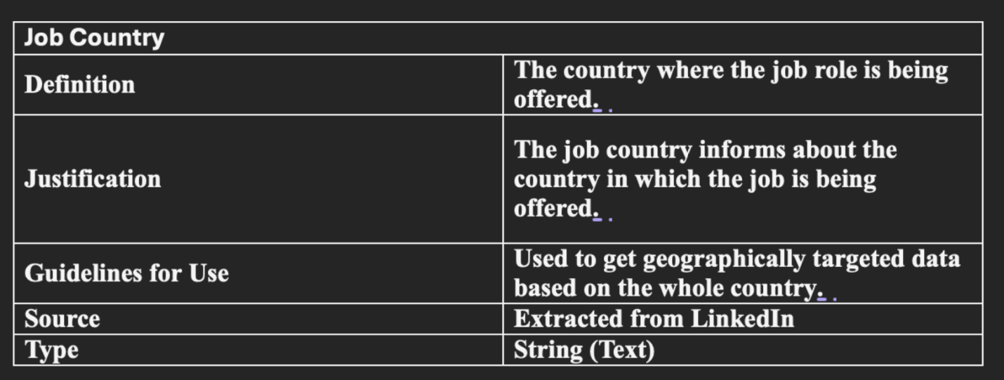

Job Title – The job title will help us refine the job listing to just that of Business Analyst roles to work on the exact data.

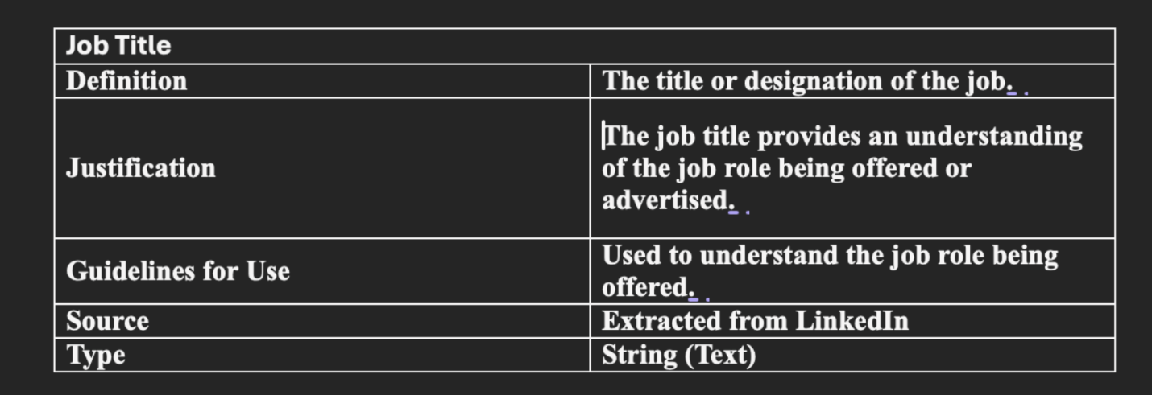

Job Links – The job links is the only variable that is present in all the datasets and will act as a joining metric for joining the datasets.

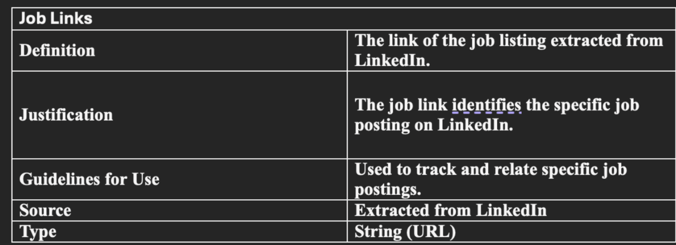

Job Skills – The job skills will help us analyse the various skills required for different types and positions of job listings.

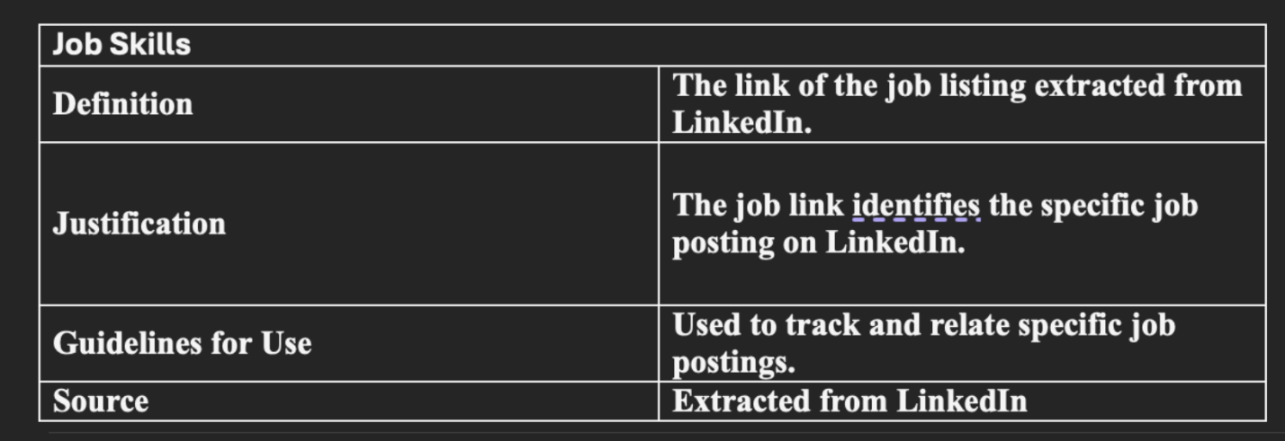

## Data Preparation

The data preparation section consists of various metrics of our analytical plan including explanation on the data cleaning, filtration and the resulting findings which have been further visualized for better understanding.

Data Cleaning

The source of our analysis consisted of 3 different datasets, the common variable in all the 3 datasets was Job Links which was then used to link and combine all three datasets.

* Removing Redundant Columns

KNIME was used for all the cleaning and filtration of the given datasets. The first step to clean the data was to remove all the redundant columns which presented no value to our analysis at any stage. An analysis of all the columns was also done to analyse to recognize any data types and if any node can be applied to define a data type for further analysis but all the resulting columns that would be used for the analysis were strings.

* Joining Datasets

Now we have all the individual datasets without the redundant columns. we analysed the common links between the 3 datasets which were the job links. We have used the job link as a common point and joined 2 datasets at a time. The final output was a common table which had all the cleaned data.

* Refining Column Names/Variables

After joining the datasets, we landed with the final table for us to start working on our analysis based on our scope of the analytical plan, but all the column names were not exactly appropriate and understandable. we renamed all the column names with respect to the relevant data they contained for better understanding and analysis in the later stages of the analysis. The output table after this step was used to create the data dictionary and to document all the various variables for working on filtration and refining of the data.

Data Filtration

For the filtration of the cleaned data, I revisited the scope of our analysis because relevant filters and metrics needed to be added on KNIME to come up with a further refined table.

* Filtration in accordance with Analysis Scope

The scope of our analysis was confined to Business Analyst roles in United States, so row filters were applied on Job Titles and Country to filter out the data which was relevant and apt for our scope of analysis. After this filtration the resulting unique values in the Job Titles was 3 which was due to difference in the capitalization which was then rectified by using string manipulation to replace all the values with one unique value. This data was then extracted in excel format to perform analysis and visualisations of the job market and their relevant metrics that will be displayed and discussed in the coming sections.

* Filtration and Conversion of Job Skills

The Job Skills variable of our filtered data was in the form of a continuous string but had different values that needed to be split and constructed into different fields in the dataset. I used KNIME to first split the string into numerous columns which were then unpivoted into one column and linked to the relevant variables.

These functions resulted in giving us the exact analysis of skills but led to repetition of all the other variables/column fields which in turn would not lead to the exact number of data being visualized to be correct. Hence, an excel extracted during this phase was then used to generate visuals with respect to the skills. Co-relation amongst all the variables/columns with respect to the job skills remained intact and hence visuals were created from this output table extracted in excel format.

The resulting skills had similar values which meant the same thing, to come up with more accurate results these skills were renamed to the string name which was repeated more time. For example – Communication and Communication Skills were two different skills which meant the same thing and were converted to Communication.

Visualisations and Description

The following visuals have been derived from the excels extracted after all the filtration and conversion of data mentioned above which gives us insight on the data being discovered and analysed for this analytical plan.

Figure-1 show the total number of Business Analyst job offerings in the United States which comes out to be 761 after filtration of job titles and country.

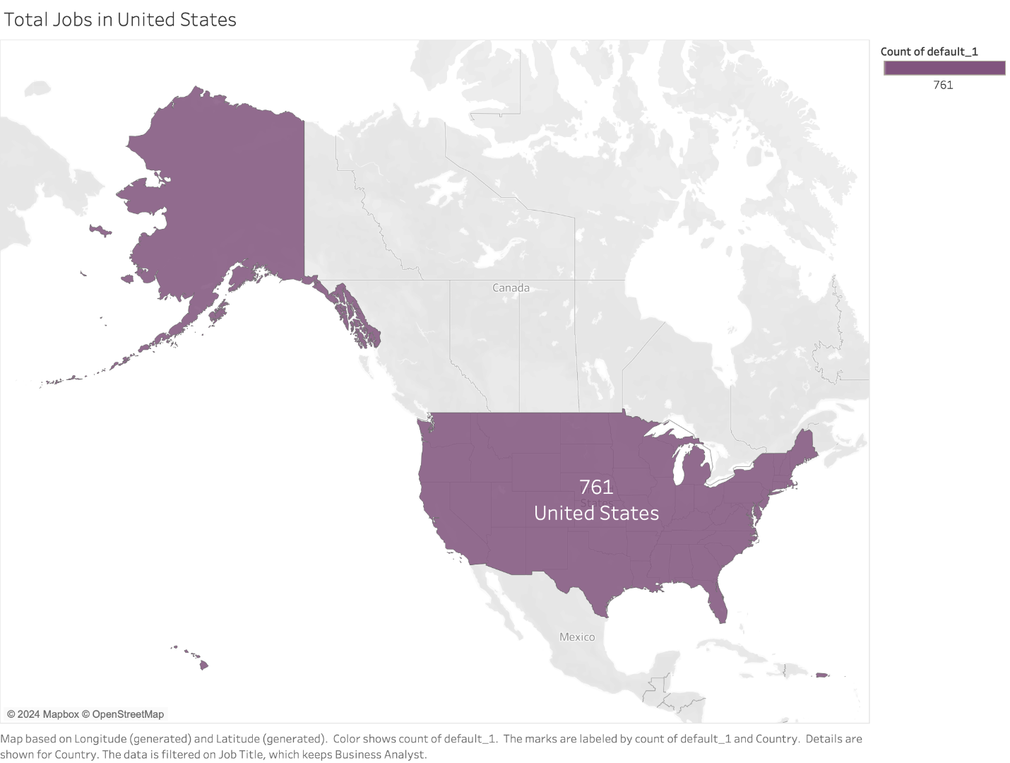

Figure 1 – Total Jobs in United States

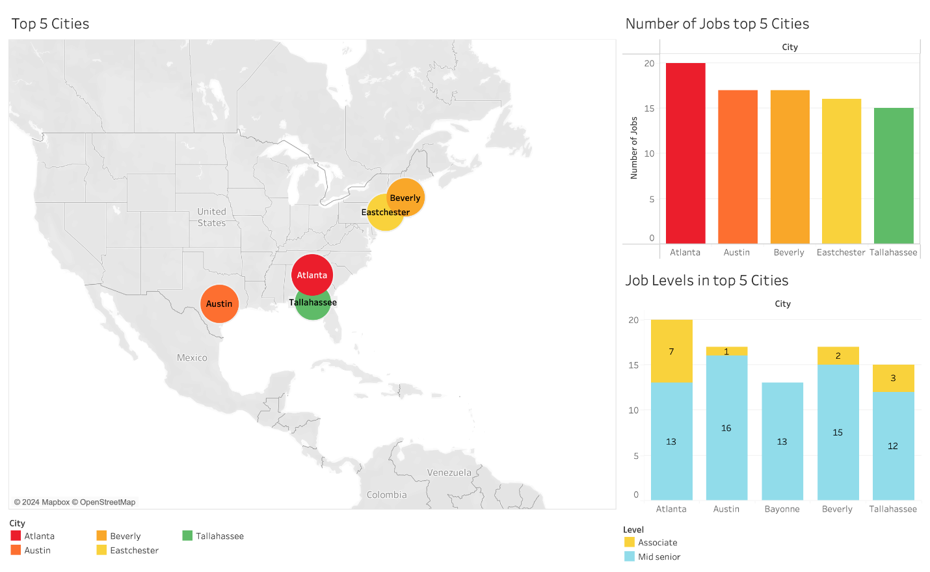

Figure 2– Top 5 Cities and Job Levels

Figure-2 shows us the top 5 cities with respect to the density of jobs being offered in United States. The cities in the map and graph have been depicted with same colour for better understanding. We can also see the bifurcation of these jobs regarding the job levels on the bottom right corner, which tells us there are more jobs for mid-senior job levels than that of associates.

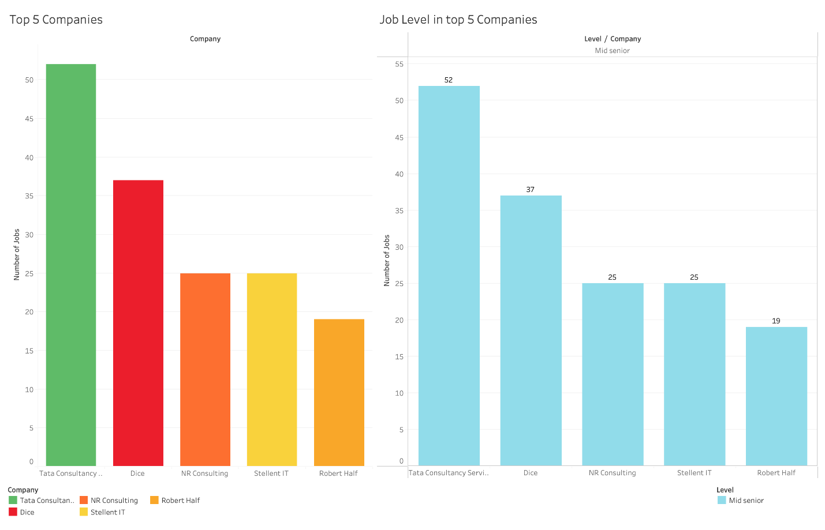

Figure 3– Top 5 Companies and Job Levels

Figure-3 depicts the top 5 companies that are offering business analyst roles along with the level of jobs being offered by these companies. We concluded that these top 5 companies are only offering mid-senior jobs and no associate jobs which suggests there are no low-level job entries in the top 5 companies of United States.

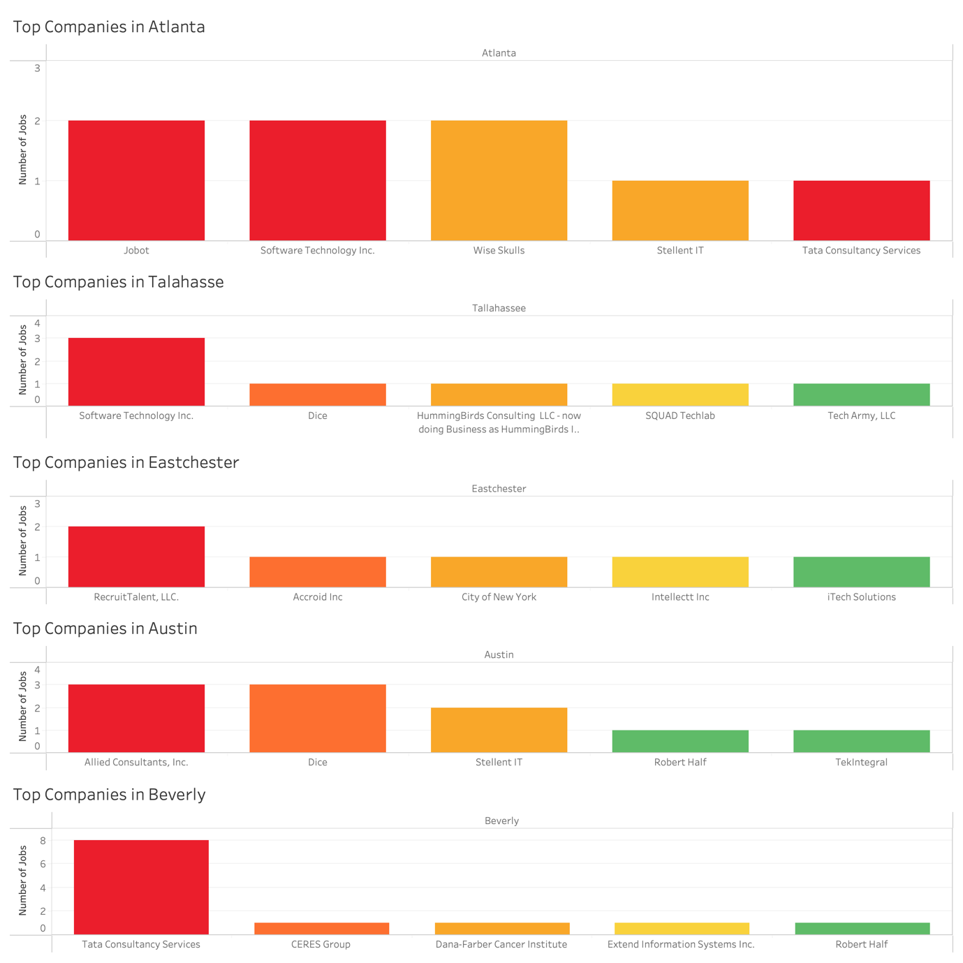

Figure-4– Top Companies in top 5 Cities

Figure-4 shows the top 5 cities with job offerings and the relevant top companies offering these jobs. We can see and analyse three common entities – Tata Consultancy Services, Dice and Robert Half amongst all the visuals which we saw in figure 3.

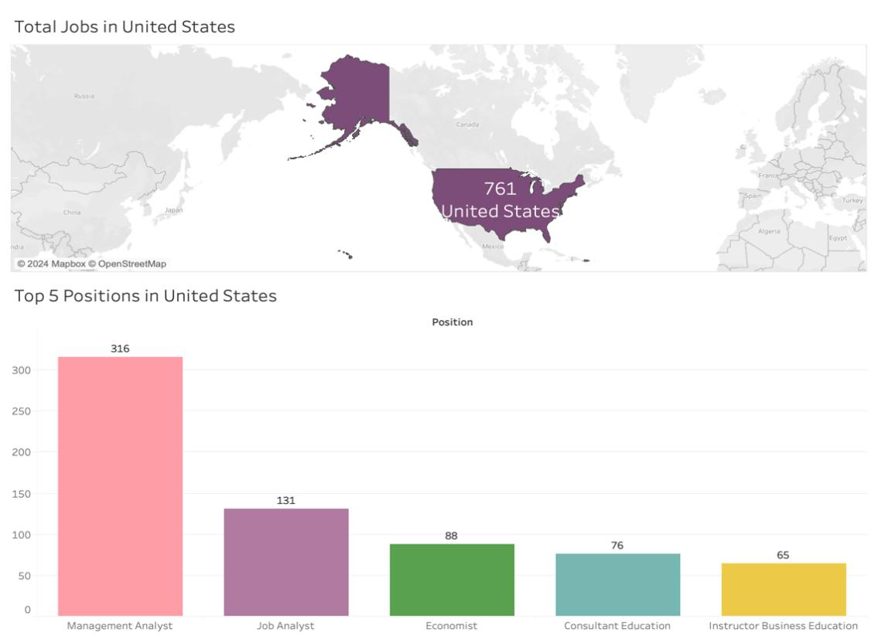

Figure-5 – Total Jobs and Top 5 Positions

From Visual 5 we can see the top 5 positions that are being offered in the United States and their respect values. Management Analyst roles are the most abundantly offered roles in the country, which account for more than 40% of the total jobs.

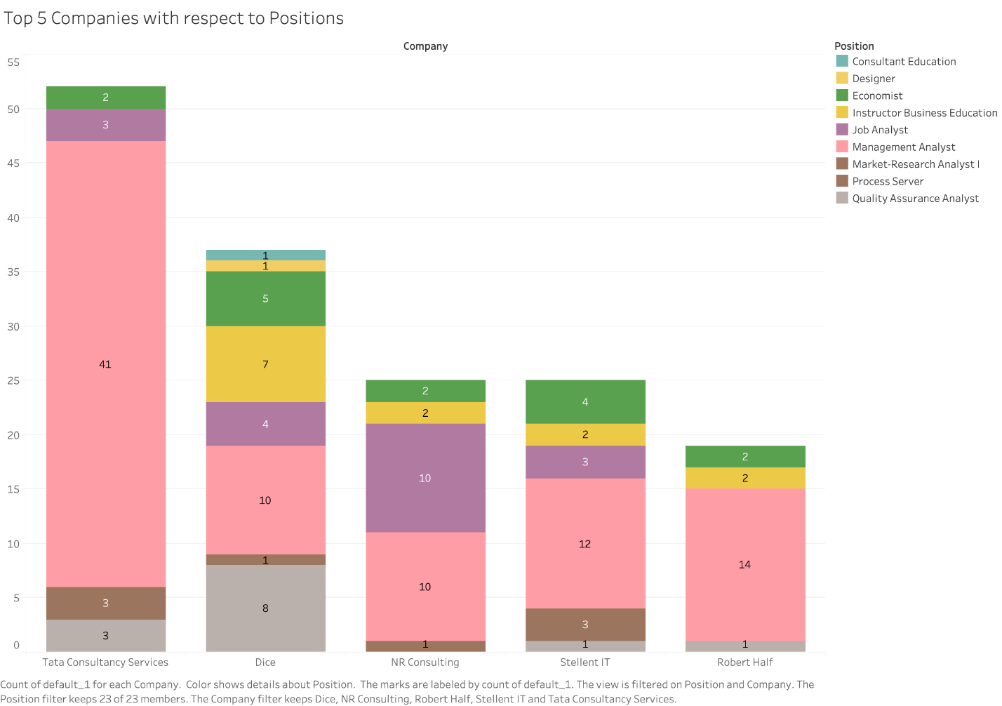

Figure-6 – Top 5 Companies and Respective Positions

Figure-6 depicts the top 5 companies and the various Positions being offered by this pool of companies; we have observed that some positions from the total distinct values of were not observed in this pool of positions. We can see that the maximum number of jobs being offered is Management Analyst, which further validates our findings of Visual 5.

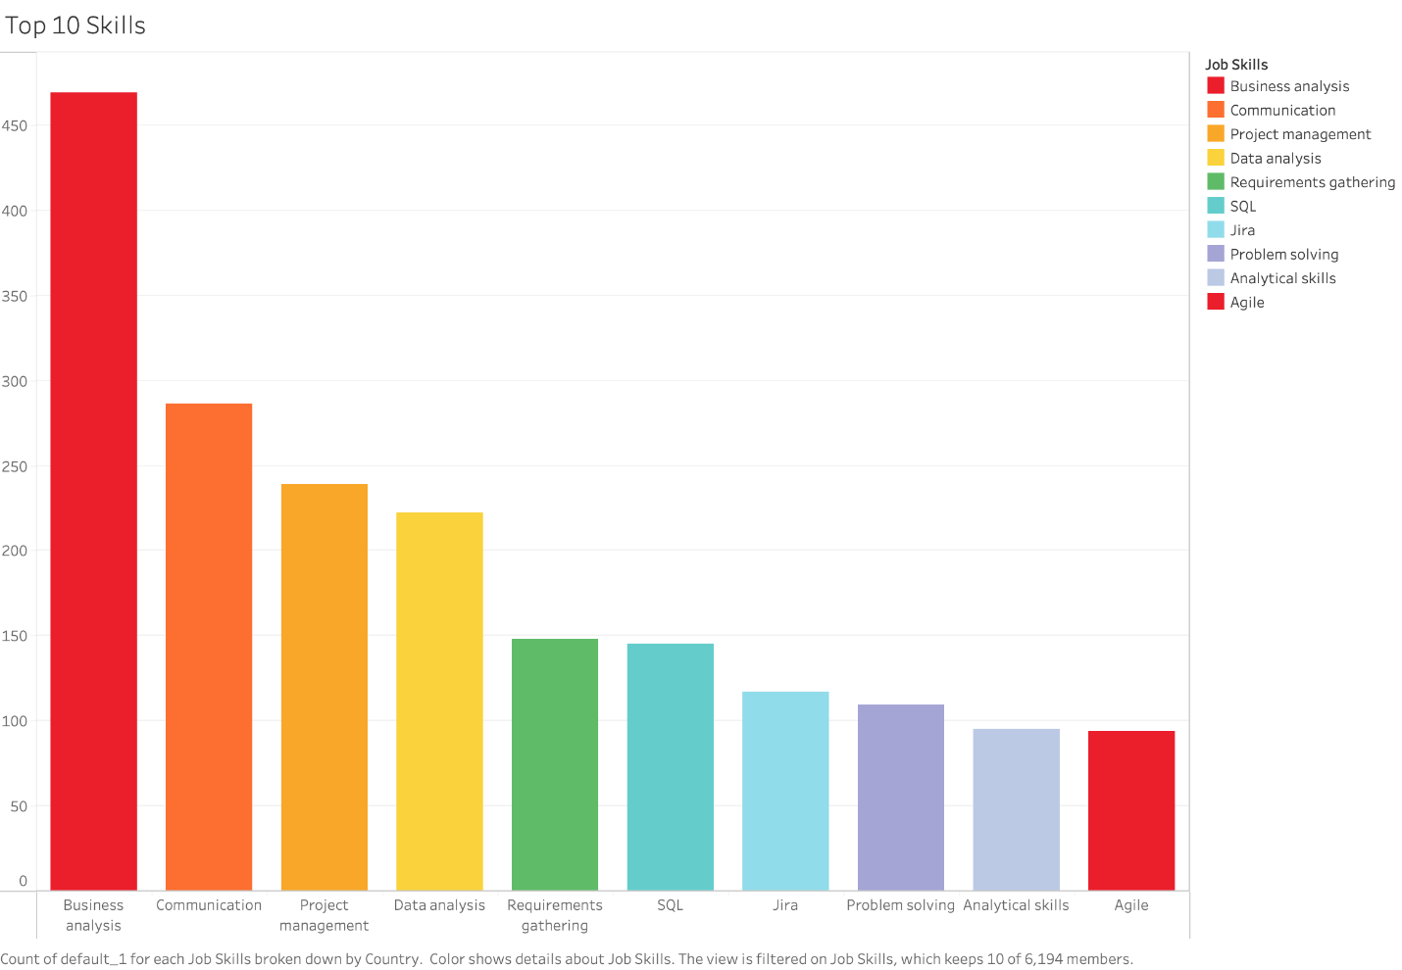

Figure-7– Top 10 Skills

Figure-7 depicts and elaborates on the Top 10 skills that are in demand in the United States for Business Analyst roles. The most sought-after skill is Business Analysis.

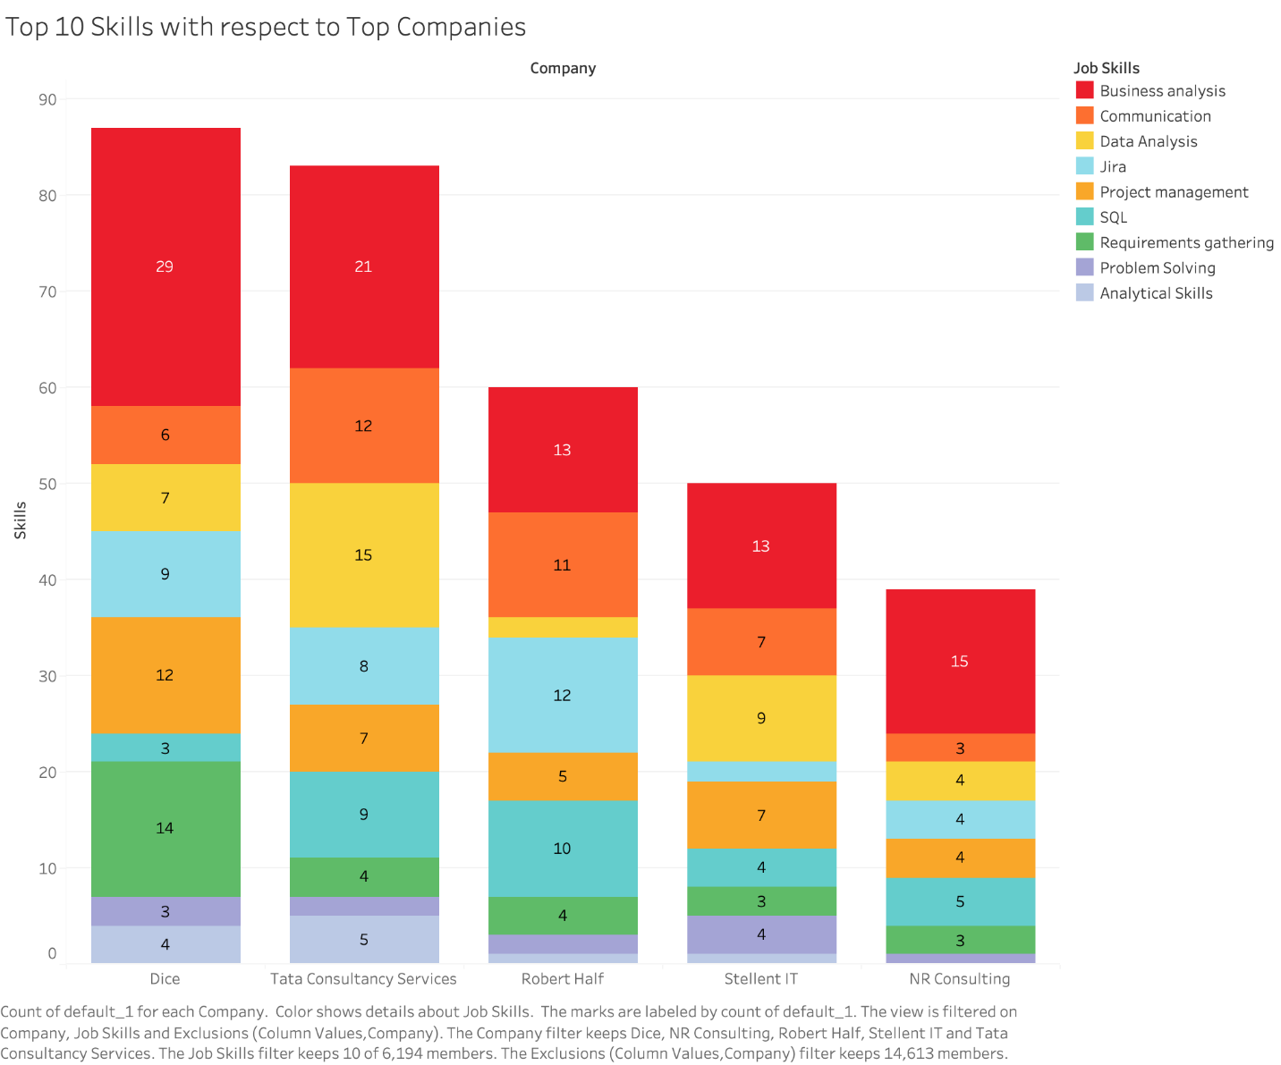

Figure-8 – Top 10 Skills with Respect to Top Companies

Figure 8 shows the top 10 skills required by the Top 5 companies we established in Visual 3. The data has been derived from the unpivoted data which had certain missing values too, but the result’s relative co-relation remains true to its value. The results from this visual also help verify and support figure 7.

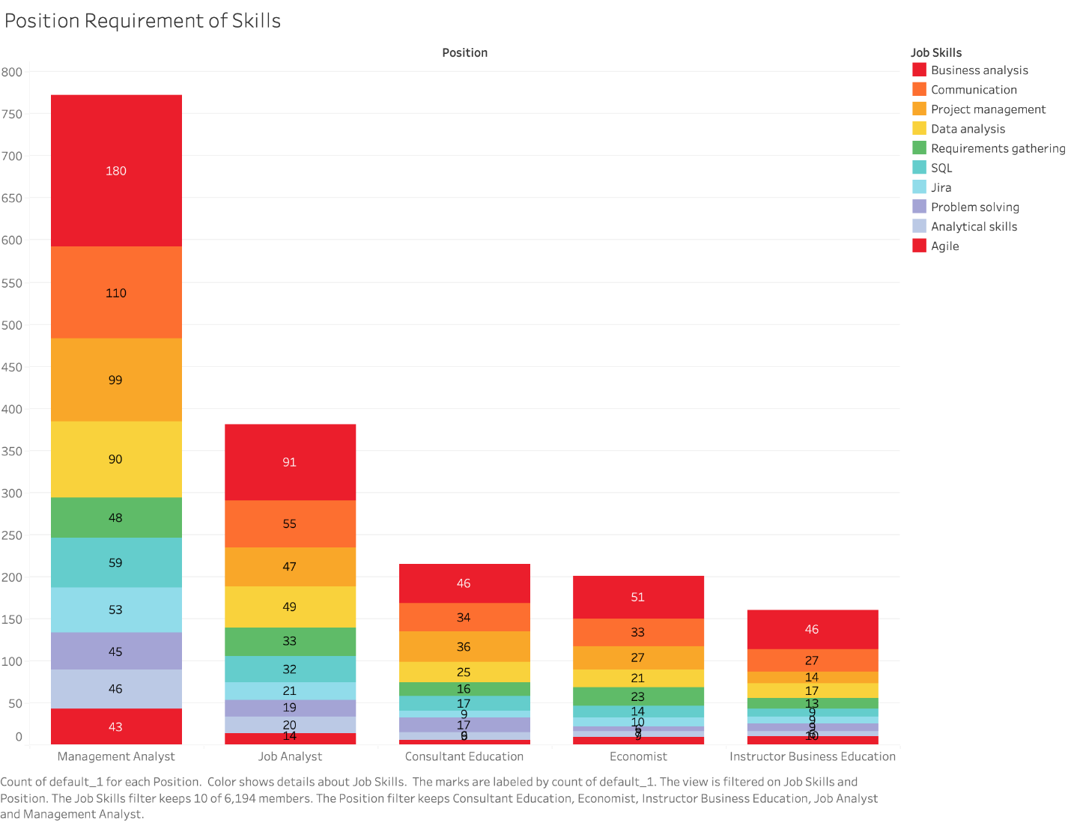

Figure-9 – Top Skills required by top Job Positions

Figure-9 gives insight into the top 10 skills sought for the top 5 job positions being offered established in Visual 5. We can clearly see that the skill required the most is business analysis. The job skills follow a similar trend for the whole data where Business Analysis is the most sought-after skill.

## Modelling

Data modelling is one of the interesting parts of this project. After data preparation, we are going to develop our models such predictive modelling (Chen et al., 2022) to address the job market trend of USA market that will help to take the decisions to the interested stakeholders. The other popular models can be explored such as decision tree (Azam et al., 2023), clustering methods (Ershadi & Seifi, 2022) and neural network modelling (Azam et al., 2023) suggested by different experts.

## Evaluation

The evaluation phase involves assessing the analysis's results to align with business objectives. It involves comparing the results with the initial objectives, interpreting the findings in the context of the job market analysis, and making final adjustments if necessary. Key tasks include validating the results against business objectives, reviewing and interpreting the findings, and making necessary adjustments. There are couple of methods are used to evaluate the analytics model and this part will be presented in the later report.

## Deployment

The deployment phase involves presenting findings and implementing them in a business context. A comprehensive report or presentation should summarize the analysis, key findings, and recommendations, tailored to stakeholders' needs. Deployment requires scalability, compatibility, integration ease, and maintenance requirements. Cloud platforms like AWS, Azure, and Google Cloud offer scalable infrastructure and managed services are popular as a deployment tools. We will provide recommendations based on our analysis capturing the insights and action plan.

# Mind Map

The Figure 10 represents the collective understanding of the problem, derived from brainstorming sessions and the distillation of individual mind maps.

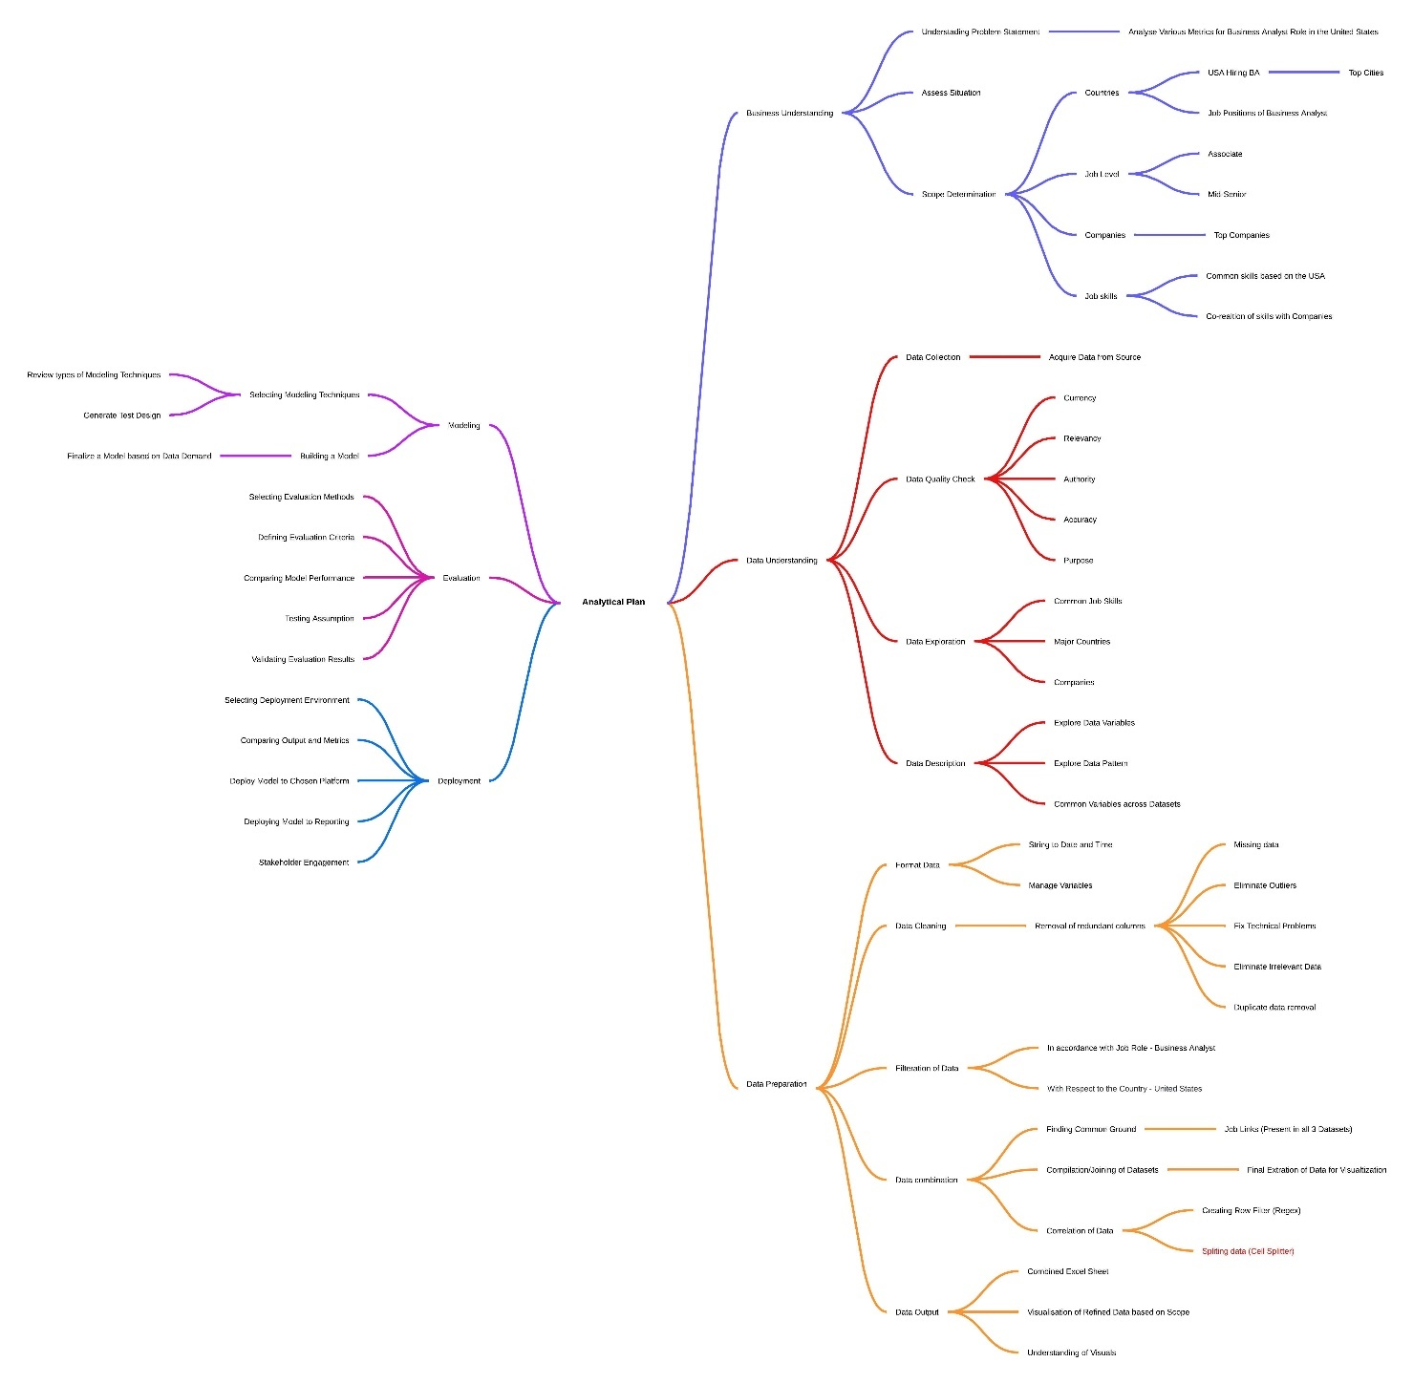

Figure 10 – Group Mind Map

# Individual Assignments

In this group, for the execution of the analytic plan, roles were clearly defined to ensure the effective execution and evaluation of tasks, Figure 11 and 12 presents the how tasks were distributed.

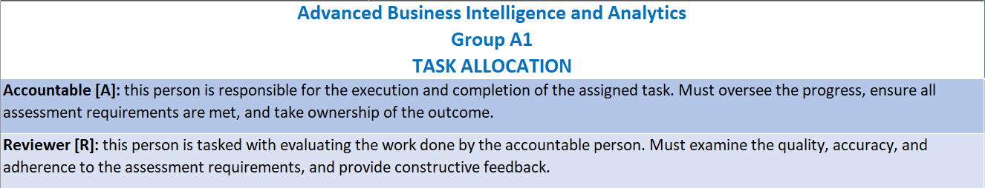Figure 11 – Roles Definition

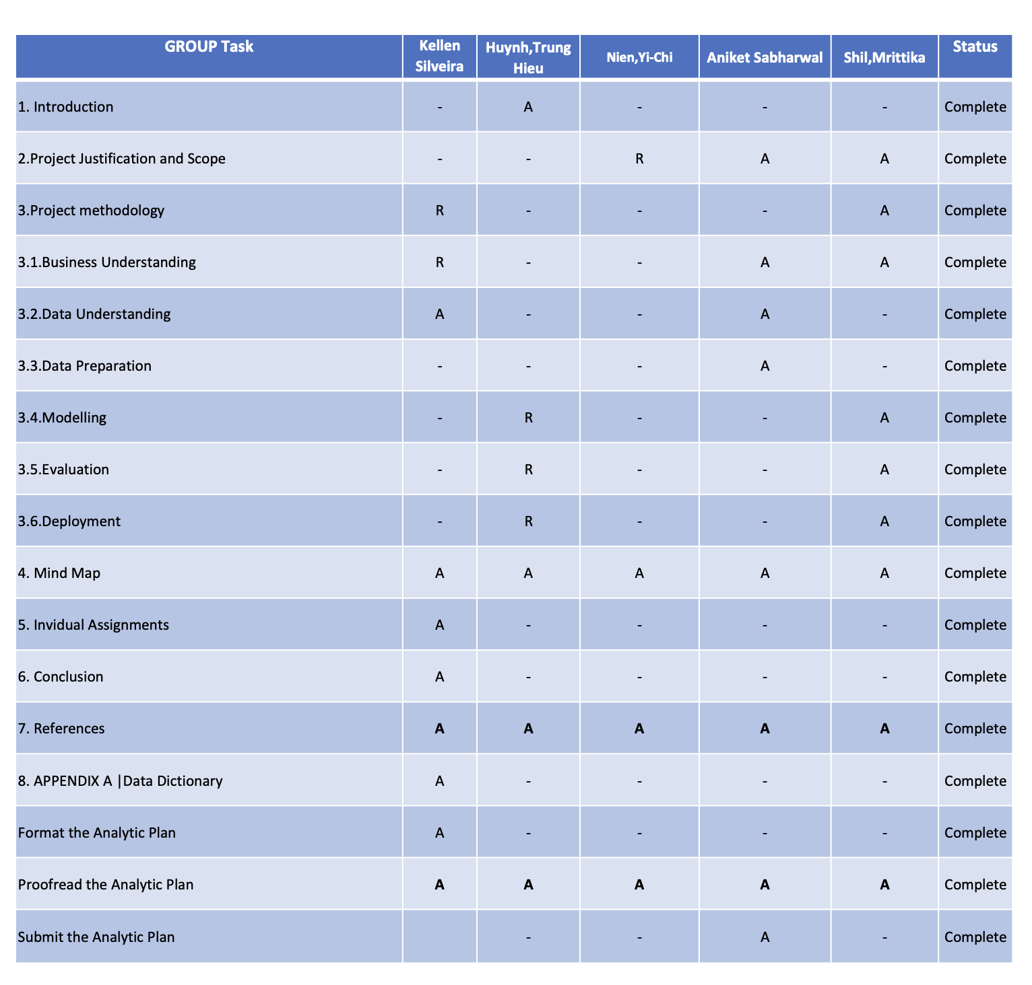

Figure 12– Task Allocation

# Conclusion

In conclusion, this analytic plan provides a comprehensive analysis of Business Analyst job trends in the U.S. based on LinkedIn data. Key findings include the distribution of job offerings, top cities, leading employers, and prevalent job levels. Visuals illustrate significant patterns, revealing a concentration of mid-senior roles and the dominance of certain cities and companies in the job market.

# References

Azam, Z., Islam, Md. M., & Huda, M. N. (2023). Comparative Analysis of Intrusion Detection

Systems and Machine Learning-Based Model Analysis Through Decision Tree. *IEEE Access*, *11*, 80348–80391. <https://doi.org/10.1109/ACCESS.2023.3296444>

Chen, T.-C., Ibrahim Alazzawi, F. J., Mavaluru, D., Mahmudiono, T., Enina, Y., Chupradit, S., Al Ayub Ahmed, A., Syed, M. H., Ismael, A. masood, & Miethlich, B. (2022). Application of Data Mining Methods in Grouping Agricultural Product Customers. *Mathematical Problems in Engineering*, *2022*(4), 1–9. <https://doi.org/10.1155/2022/3942374>

Dev, S., Wang, H., Nwosu, C. S., Jain, N., Veeravalli, B., & John, D. (2022). A predictive analytics approach for stroke prediction using machine learning and neural networks. *Healthcare Analytics*, *2*, 100032. <https://doi.org/10.1016/j.health.2022.100032>

Ershadi, M. M., & Seifi, A. (2022). Applications of dynamic feature selection and clustering methods to medical diagnosis. *Applied Soft Computing*, *126*, 109293. <https://doi.org/10.1016/j.asoc.2022.109293>

Gökalp, M. O., Gökalp, E., Kayabay, K., Gökalp, S., Koçyiğit, A., & Eren, P. E. (2022). A process assessment model for big data analytics. *Computer Standards & Interfaces*, *80*, 103585. <https://doi.org/10.1016/j.csi.2021.103585>

Jamie Smith. (2024, February 9). *Demystifying The Process: Best Practices For Evaluating Predictive Analytics Models | Learnexus*. Learnexus. <https://learnexus.com/best-practices-for-evaluating-predictive-analytics-models/#:~:text=The%20evaluation%20of%20predictive%20analytics>

Jeison Vásquez, Ojeda, P., & Wong, L. (2024). Model to Predict Incoming Tech Support Demand in a Banking Company Applying CRISP-DM and Machine Learning.  *2024 14th International Conference on Cloud Computing, Data Science & Engineering (Confluence)*. <https://doi.org/10.1109/confluence60223.2024.10463443>

Lawal, K. N., Olaniyi, T. K., & Gibson, R. M. (2024). CRISP-DM User Mobility Determined IoT Placement Within a Real-World Smart Building for Resource Efficient Fog Computing Environments. *Lecture Notes in Networks and Systems*, 520–542. <https://doi.org/10.1007/978-3-031-62273-1_33>

Masini, R. P., Medeiros, M. C., & Mendes, E. F. (2021). Machine learning advances for time series forecasting. *Journal of Economic Surveys*, *37*(1). <https://doi.org/10.1111/joes.12429>

Rousseeuw, P. J., & Hubert, M. (2011). Robust statistics for outlier detection. *Wiley Interdisciplinary Reviews: Data Mining and Knowledge Discovery*, *1*(1), 73–79. <https://doi.org/10.1002/widm.2>

Saltz, J. S. (2021). CRISP-DM for Data Science: Strengths, Weaknesses and Potential next Steps. *2021 IEEE International Conference on Big Data (Big Data)*.

Sarabia-Jácome, D., Lacalle, I., Palau, C. E., & Esteve, M. (2019). *Efficient Deployment of Predictive Analytics in Edge Gateways: Fall Detection Scenario*. <https://doi.org/10.1109/wf-iot.2019.8767231>

Schröer, C., Kruse, F., & Gómez, J. M. (2021). A Systematic Literature Review on Applying CRISP-DM Process Model. *Procedia Computer Science*, *181*(1), 526–534.

*What are the best ways to deploy a model in predictive analytics?* (2024). Linkedin.com. <https://www.linkedin.com/advice/3/what-best-ways-deploy-model-predictive-analytics-ygkwc>

*What is the best way to evaluate a predictive analytics model’s accuracy?* (2024). Linkedin.com. <https://www.linkedin.com/advice/3/what-best-way-evaluate-predictive-analytics-models-9qyuf>

Yin, J., Rao, W., Yuan, M., Zeng, J., Zhao, K., Zhang, C., Li, J., & Zhao, Q. (2019). *Experimental Study of Multivariate Time Series Forecasting Models*. <https://doi.org/10.1145/3357384.3357826>

# APPENDICES

## APPENDIX A | Data Dictionary

The data dictionary serves as a reference guide, ensuring consistency and clarity in how the data is interpreted and utilized throughout the analytic plan.

|  |  |
| --- | --- |
| Job Link | |
| Definitions | A URL link to a detailed and specific job posting on LinkedIn. |
| Justifications | Provides direct access to the job listing for further details and verification. |
| Guidelines of Use | Verify that the link is active and correctly directs to the intended job posting. Periodically check for link validity as job postings may expire. |
| Data Type | String (URL) |
| Scope | Unique for each job listing, providing a direct reference to the original post. |
| Source | Data is derived from job postings such as those available on LinkedIn and collected datasets like [Kaggle - 1.3M LinkedIn Jobs and Skills 2024](https://www.kaggle.com/datasets/asaniczka/1-3m-linkedin-jobs-and-skills-2024). |

|  |  |
| --- | --- |
| Job Title | |
| Definitions | The title of the job position being advertised. |
| Justifications | Identifies the role being offered and is crucial for classification and categorisation in analysis, and for job seekers looking for specific titles. |
| Guidelines of Use | Use the exact job title as provided by the employer to ensure accuracy and consistency. Standardize common roles to avoid duplicates with different naming conventions. |
| Data Type | String (Text) - though standardization may be applied. |
| Scope | Specific to each job listing. |
| Source | Data is derived from job postings such as those available on LinkedIn and collected datasets like [Kaggle - 1.3M LinkedIn Jobs and Skills 2024](https://www.kaggle.com/datasets/asaniczka/1-3m-linkedin-jobs-and-skills-2024). |

|  |  |
| --- | --- |
| Company | |
| Definitions | The name of the company that is hiring for the job position. |
| Justifications | Identifies the employer, which is essential for company-specific analysis and understanding industry trends. Also, allowing job seekers to search for opportunities by company name. |
| Guidelines of Use | Ensure the company name is recorded accurately and consistently. Avoid abbreviations unless commonly recognized. |
| Data Type | String (Text) |
| Scope | Unique to each job listing, representing the hiring company. |
| Source | Data is derived from job postings such as those available on LinkedIn and collected datasets like [Kaggle - 1.3M LinkedIn Jobs and Skills 2024](https://www.kaggle.com/datasets/asaniczka/1-3m-linkedin-jobs-and-skills-2024). |

|  |  |
| --- | --- |
| Job Location | |
| Definitions | The physical location of the job, including the city and state. |
| Justifications | Indicates where the job is based, which is important for geographical analysis and understanding the distribution of job opportunities. Also, helps job seekers filter opportunities by geographic location. |
| Guidelines of Use | Ensure the location is recorded in a standard format (e.g., "City, State"). |
| Data Type | Standardized geographic locations/addresses. |
| Scope | Location-specific to each job posting. |
| Source | Data is derived from job postings such as those available on LinkedIn and collected datasets like [Kaggle - 1.3M LinkedIn Jobs and Skills 2024](https://www.kaggle.com/datasets/asaniczka/1-3m-linkedin-jobs-and-skills-2024). |

|  |  |
| --- | --- |
| Job City | |
| Definitions | The city where the job search is focused or where the job is located. |
| Justifications | Used for filtering and analysing job opportunities by city, providing insights into local job markets. |
| Guidelines of Use | Record the city name accurately. If the job is remote or flexible, indicate this clearly. |
| Data Type | String (Text) - though standardization may be applied. |
| Scope | Specific to each job listing. |
| Source | Data is derived from job postings such as those available on LinkedIn and collected datasets like [Kaggle - 1.3M LinkedIn Jobs and Skills 2024](https://www.kaggle.com/datasets/asaniczka/1-3m-linkedin-jobs-and-skills-2024). |

|  |  |
| --- | --- |
| Job Country | |
| Definitions | The country where the job is located or where the job search is focused. |
| Justifications | Essential for geographical analysis and understanding the distribution of job opportunities across different countries. |
| Guidelines of Use | Ensure the country is accurately recorded. Use the full country name rather than abbreviations. |
| Data Type | String (Text) - though standardization may be applied. |
| Scope | Specific to each job listing. |
| Source | Data is derived from job postings such as those available on LinkedIn and collected datasets like [Kaggle - 1.3M LinkedIn Jobs and Skills 2024](https://www.kaggle.com/datasets/asaniczka/1-3m-linkedin-jobs-and-skills-2024). |

|  |  |
| --- | --- |
| Job Position | |
| Definitions | The general position or category of the job, often aligned with the job title. |
| Justifications | Helps in categorising jobs into broader roles or functions for analysis. |
| Guidelines of Use | Ensure the position is clearly defined and matches the job title. Use consistent terminology across entries. |
| Data Type | String (Text) |
| Scope | Broad categorisation of the job role. |
| Source | Data is derived from job postings such as those available on LinkedIn and collected datasets like [Kaggle - 1.3M LinkedIn Jobs and Skills 2024](https://www.kaggle.com/datasets/asaniczka/1-3m-linkedin-jobs-and-skills-2024). |

|  |  |
| --- | --- |
| Job Level | |
| Definitions | The seniority level of the job position. |
| Justifications | Identifies the experience level required, which is crucial for candidates and for market segmentation. |
| Guidelines of Use | Use the job level as specified by the employer. Standardise the terminology where possible (e.g., Associate, Mid Senior) |
| Data Type | Picklist (Associate, Mid Senior) |
| Scope | Represents the required seniority for the job role. |
| Source | Data is derived from job postings such as those available on LinkedIn and collected datasets like [Kaggle - 1.3M LinkedIn Jobs and Skills 2024](https://www.kaggle.com/datasets/asaniczka/1-3m-linkedin-jobs-and-skills-2024). |

|  |  |
| --- | --- |
| Job Type | |
| Definitions | The nature of the job in terms of work arrangement (e.g., Onsite, Remote). |
| Justifications | Indicates the work environment, which is crucial for candidates with specific preferences or requirements. |
| Guidelines of Use | Record the job type exactly as specified by the employer. If the job type is hybrid, indicate the proportion of onsite versus remote work if available. |
| Data Type | Picklist (Hybrid, Onsite, Remote) |
| Scope | Specific to each job listing. |
| Source | Data is derived from job postings such as those available on LinkedIn and collected datasets like [Kaggle - 1.3M LinkedIn Jobs and Skills 2024](https://www.kaggle.com/datasets/asaniczka/1-3m-linkedin-jobs-and-skills-2024). |

|  |  |
| --- | --- |
| Job Skills | |
| Definitions | Specific abilities, competencies, and qualifications required to perform tasks effectively in various job roles, including both hard skills (technical, specialized knowledge) and soft skills (communication, leadership, etc.). |
| Justifications | Critical for identifying and categorizing positions across different industries. Helps job seekers understand requirements and employers specify expectations. Supports filtering and analysis of job listings, aiding market research and career planning. |
| Guidelines of Use | Use the exact job skills as listed by employers to ensure data accuracy. |
| Standardize common skill terms to avoid duplicates (e.g., "Project Management" vs. "Project Planning"). |
| Categorize skills into relevant groups (e.g., technical, managerial, healthcare-specific) to facilitate analysis and reporting. |
| Data Type | String (Text) - though standardization may be applied. |
| Scope | Specific to each job listing. Skills cover a wide range of sectors (e.g., healthcare, IT, construction, sales, manufacturing). Must be updated and expanded to reflect industry trends and demands. |
| Source | Data is derived from job postings such as those available on LinkedIn and collected datasets like [Kaggle - 1.3M LinkedIn Jobs and Skills 2024](https://www.kaggle.com/datasets/asaniczka/1-3m-linkedin-jobs-and-skills-2024). |

|  |  |
| --- | --- |
| Job Summary | |
| Definitions | A description of the job role, outlining key responsibilities, tasks, and expectations. |
| Justifications | Provides a summary of the job's core duties and required expertise, useful for quickly assessing the role's requirements. |
| Guidelines of Use | Ensure the summary is a concise reflection of the full job description. It should cover the main aspects of the role without extraneous details. |
| Data Type | String (Long Text) |
| Scope | Summarises the responsibilities and duties associated with the job role. |
| Source | Data is derived from job postings such as those available on LinkedIn and collected datasets like [Kaggle - 1.3M LinkedIn Jobs and Skills 2024](https://www.kaggle.com/datasets/asaniczka/1-3m-linkedin-jobs-and-skills-2024). |

## APPENDIX B | Kellen V. H. Silveira – HERKY010

### Appendix B.1 | Bibliography

This appendix contains the evaluation of two sources that were identified, read, and assessed using the CRAAP test. The CRAAP test (Currency, Relevance, Authority, Accuracy, and Purpose) was applied to ensure that the materials are reliable, relevant, and suitable for informing the group's work.

CRAAP Test 1:

Kahn, M. (2023). *Data Exploration and Preparation with BigQuery : A Practical Guide to Cleaning, Transforming, and Analyzing Data for Business Insights* (First edition.). Packt Publishing Ltd.

|  |  |
| --- | --- |
| CRAAP Test 1 | |
| Currency | The book was published in 2023, making it a very current source. This is crucial for the analysis of job market data from 2024, ensuring that the techniques and tools discussed are up-to-date and relevant to the current technological landscape, particularly in the context of using BigQuery for data exploration and preparation. |
| Relevance | The content of the book is highly relevant to your analytic plan as it covers the use of BigQuery for data exploration and preparation. This aligns directly with your need to handle and analyse large job datasets, including tasks such as decomposing skills and matching them to job descriptions. The book provides practical guidance that can be applied to your specific project requirements. |
| Authority | The author, Mike Kahn, is published by Packt Publishing, a reputable publisher known for its technical books in the data and technology sectors. While the author’s specific credentials are not detailed, the authority of the publisher and the practical focus of the book contribute to its reliability as a source. |
| Accuracy | The book is supported by practical exercises, case studies, and references, which enhance the accuracy of its content. These elements ensure that the methods and techniques discussed are tested and applicable in real-world scenarios. This accuracy is essential for ensuring that your analysis of LinkedIn job listings is based on sound data preparation practices. |
| Purpose | The book’s purpose is to provide practical, hands-on knowledge for data professionals using BigQuery, with a focus on data exploration and preparation. There is no evident bias, and the content is designed to be instructional and informative, making it well-suited for your task of preparing and analysing large datasets related to the job market for business analyst qualifications |

CRAAP Test 2:

Po, L. (2020). *Linked Data Visualisation: Techniques, Tools, and Big Data* (1st edition.). Springer Nature.

|  |  |
| --- | --- |
| CRAAP Test 2 | |
| Currency | The book was published in 2020, making it relatively recent and suitable for use in the context of modern data visualisation techniques. Although it is not as current as the 2023 source, it is still relevant for understanding the developments in Linked Data visualisation, which is crucial for analysing large datasets in the job market research scenario. |
| Relevance | The content is highly relevant to your analytic plan, particularly in the context of visualising large datasets. The book's focus on techniques, tools, and use cases of visualisation aligns with your need to analyse and present data effectively, making it a valuable resource for exploring and communicating patterns in the job market data you are working with. |
| Authority | The authors—Laura Po, Nikos Bikakis, Federico Desimoni, and George Papastefanatos—are experts in the field of Linked Data and information visualisation. The book is published by Springer Nature, a well-respected academic publisher, which adds to the authority and credibility of the content. The combination of recognised authors and a reputable publisher makes this a reliable source. |
| Accuracy | The book is supported by a wide range of references, case studies, and practical examples, ensuring that the information provided is accurate and based on solid research. This level of accuracy is essential for your task, as it ensures that the visualisation techniques you employ are grounded in proven methodologies, enhancing the reliability of your findings. |
| Purpose | The book’s purpose is to provide a comprehensive guide to Linked Data visualisation, offering insights into the latest techniques and tools. It is designed to be educational, serving both as a course textbook and a practical guide. There is no evident bias, and the content is presented objectively, making it well-suited for your analytic plan on the job market for business analyst qualifications. |

### Appendix B.2 | Mind Map

The mind map developed as part of the individual preparation for the group discussion on the job market analysis for business analysts in 2024. This initial exploration lays the groundwork for a more focused and collaborative analysis within the group.

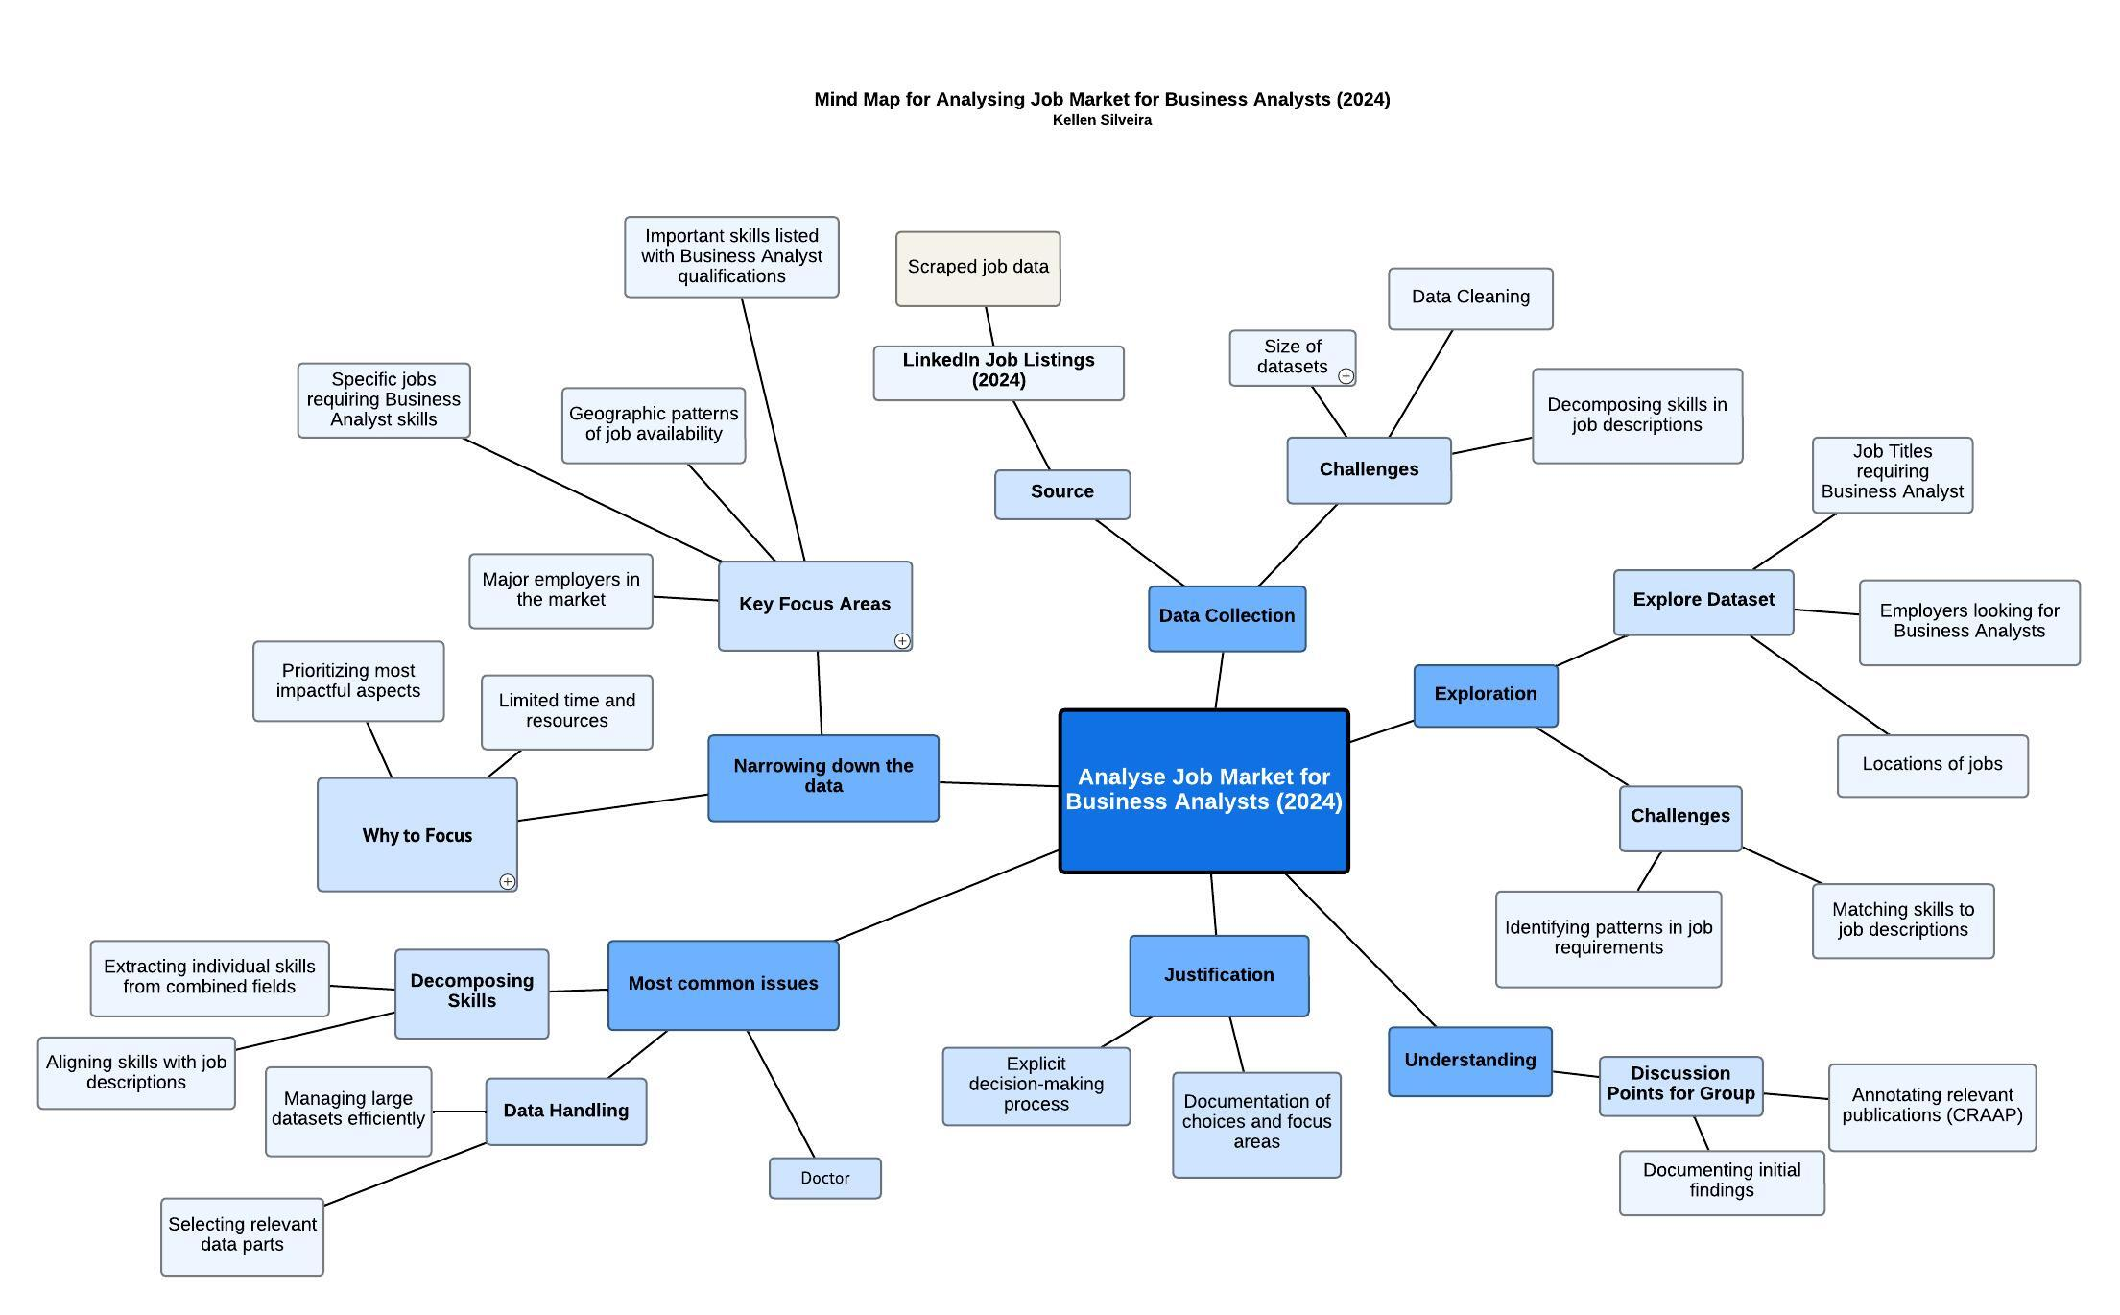

### Appendix B.3 | Data Dictionary

The data dictionary serves as a reference guide, ensuring consistency and clarity in how the data is interpreted and utilized throughout the analysis.

|  |  |
| --- | --- |
| Job Link | |
| Definitions | A URL link to a detailed and specific job posting on LinkedIn. |
| Justifications | Provides direct access to the job listing for further details and verification. |
| Guidelines of Use | Verify that the link is active and correctly directs to the intended job posting. Periodically check for link validity as job postings may expire. |
| Data Type | String (URL) |
| Scope | Unique for each job listing, providing a direct reference to the original post. |
| Source | Data is derived from job postings such as those available on LinkedIn and collected datasets like [Kaggle - 1.3M LinkedIn Jobs and Skills 2024](https://www.kaggle.com/datasets/asaniczka/1-3m-linkedin-jobs-and-skills-2024). |

|  |  |
| --- | --- |
| Job Title | |
| Definitions | The title of the job position being advertised. |
| Justifications | Identifies the role being offered and is crucial for classification and categorisation in analysis, and for job seekers looking for specific titles. |
| Guidelines of Use | Use the exact job title as provided by the employer to ensure accuracy and consistency. Standardize common roles to avoid duplicates with different naming conventions. |
| Data Type | String (Text) - though standardization may be applied. |
| Scope | Specific to each job listing. |
| Source | Data is derived from job postings such as those available on LinkedIn and collected datasets like [Kaggle - 1.3M LinkedIn Jobs and Skills 2024](https://www.kaggle.com/datasets/asaniczka/1-3m-linkedin-jobs-and-skills-2024). |

|  |  |
| --- | --- |
| Company | |
| Definitions | The name of the company that is hiring for the job position. |
| Justifications | Identifies the employer, which is essential for company-specific analysis and understanding industry trends. Also, allowing job seekers to search for opportunities by company name. |
| Guidelines of Use | Ensure the company name is recorded accurately and consistently. Avoid abbreviations unless commonly recognized. |
| Data Type | String (Text) |
| Scope | Unique to each job listing, representing the hiring company. |
| Source | Data is derived from job postings such as those available on LinkedIn and collected datasets like [Kaggle - 1.3M LinkedIn Jobs and Skills 2024](https://www.kaggle.com/datasets/asaniczka/1-3m-linkedin-jobs-and-skills-2024). |

|  |  |
| --- | --- |
| Job Location | |
| Definitions | The physical location of the job, including the city and state. |
| Justifications | Indicates where the job is based, which is important for geographical analysis and understanding the distribution of job opportunities. Also, helps job seekers filter opportunities by geographic location. |
| Guidelines of Use | Ensure the location is recorded in a standard format (e.g., "City, State"). |
| Data Type | Standardized geographic locations/addresses. |
| Scope | Location-specific to each job posting. |
| Source | Data is derived from job postings such as those available on LinkedIn and collected datasets like [Kaggle - 1.3M LinkedIn Jobs and Skills 2024](https://www.kaggle.com/datasets/asaniczka/1-3m-linkedin-jobs-and-skills-2024). |

|  |  |
| --- | --- |
| Job City | |
| Definitions | The city where the job search is focused or where the job is located. |
| Justifications | Used for filtering and analysing job opportunities by city, providing insights into local job markets. |
| Guidelines of Use | Record the city name accurately. If the job is remote or flexible, indicate this clearly. |
| Data Type | String (Text) - though standardization may be applied. |
| Scope | Specific to each job listing. |
| Source | Data is derived from job postings such as those available on LinkedIn and collected datasets like [Kaggle - 1.3M LinkedIn Jobs and Skills 2024](https://www.kaggle.com/datasets/asaniczka/1-3m-linkedin-jobs-and-skills-2024). |

|  |  |
| --- | --- |
| Job Country | |
| Definitions | The country where the job is located or where the job search is focused. |
| Justifications | Essential for geographical analysis and understanding the distribution of job opportunities across different countries. |
| Guidelines of Use | Ensure the country is accurately recorded. Use the full country name rather than abbreviations. |
| Data Type | String (Text) - though standardization may be applied. |
| Scope | Specific to each job listing. |
| Source | Data is derived from job postings such as those available on LinkedIn and collected datasets like [Kaggle - 1.3M LinkedIn Jobs and Skills 2024](https://www.kaggle.com/datasets/asaniczka/1-3m-linkedin-jobs-and-skills-2024). |

|  |  |
| --- | --- |
| Job Position | |
| Definitions | The general position or category of the job, often aligned with the job title. |
| Justifications | Helps in categorising jobs into broader roles or functions for analysis. |
| Guidelines of Use | Ensure the position is clearly defined and matches the job title. Use consistent terminology across entries. |
| Data Type | String (Text) |
| Scope | Broad categorisation of the job role. |
| Source | Data is derived from job postings such as those available on LinkedIn and collected datasets like [Kaggle - 1.3M LinkedIn Jobs and Skills 2024](https://www.kaggle.com/datasets/asaniczka/1-3m-linkedin-jobs-and-skills-2024). |

|  |  |
| --- | --- |
| Job Level | |
| Definitions | The seniority level of the job position. |
| Justifications | Identifies the experience level required, which is crucial for candidates and for market segmentation. |
| Guidelines of Use | Use the job level as specified by the employer. Standardise the terminology where possible (e.g., Associate, Mid Senior) |
| Data Type | Picklist (Associate, Mid Senior) |
| Scope | Represents the required seniority for the job role. |
| Source | Data is derived from job postings such as those available on LinkedIn and collected datasets like [Kaggle - 1.3M LinkedIn Jobs and Skills 2024](https://www.kaggle.com/datasets/asaniczka/1-3m-linkedin-jobs-and-skills-2024). |

|  |  |
| --- | --- |
| Job Type | |
| Definitions | The nature of the job in terms of work arrangement (e.g., Onsite, Remote). |
| Justifications | Indicates the work environment, which is crucial for candidates with specific preferences or requirements. |
| Guidelines of Use | Record the job type exactly as specified by the employer. If the job type is hybrid, indicate the proportion of onsite versus remote work if available. |
| Data Type | Picklist (Hybrid, Onsite, Remote) |
| Scope | Specific to each job listing. |
| Source | Data is derived from job postings such as those available on LinkedIn and collected datasets like [Kaggle - 1.3M LinkedIn Jobs and Skills 2024](https://www.kaggle.com/datasets/asaniczka/1-3m-linkedin-jobs-and-skills-2024). |

|  |  |
| --- | --- |
| Job Skills | |
| Definitions | Specific abilities, competencies, and qualifications required to perform tasks effectively in various job roles, including both hard skills (technical, specialized knowledge) and soft skills (communication, leadership, etc.). |
| Justifications | Critical for identifying and categorizing positions across different industries. Helps job seekers understand requirements and employers specify expectations. Supports filtering and analysis of job listings, aiding market research and career planning. |
| Guidelines of Use | Use the exact job skills as listed by employers to ensure data accuracy. |
| Standardize common skill terms to avoid duplicates (e.g., "Project Management" vs. "Project Planning"). |
| Categorize skills into relevant groups (e.g., technical, managerial, healthcare-specific) to facilitate analysis and reporting. |
| Data Type | String (Text) - though standardization may be applied. |
| Scope | Specific to each job listing. Skills cover a wide range of sectors (e.g., healthcare, IT, construction, sales, manufacturing). Must be updated and expanded to reflect industry trends and demands. |
| Source | Data is derived from job postings such as those available on LinkedIn and collected datasets like [Kaggle - 1.3M LinkedIn Jobs and Skills 2024](https://www.kaggle.com/datasets/asaniczka/1-3m-linkedin-jobs-and-skills-2024). |

|  |  |
| --- | --- |
| Job Summary | |
| Definitions | A description of the job role, outlining key responsibilities, tasks, and expectations. |
| Justifications | Provides a summary of the job's core duties and required expertise, useful for quickly assessing the role's requirements. |
| Guidelines of Use | Ensure the summary is a concise reflection of the full job description. It should cover the main aspects of the role without extraneous details. |
| Data Type | String (Long Text) |
| Scope | Summarises the responsibilities and duties associated with the job role. |
| Source | Data is derived from job postings such as those available on LinkedIn and collected datasets like [Kaggle - 1.3M LinkedIn Jobs and Skills 2024](https://www.kaggle.com/datasets/asaniczka/1-3m-linkedin-jobs-and-skills-2024). |

### Appendix B.4 | Result of Exploring the Data

The group worked collectively on filtering the dataset, however, Aniket was the key team member working on the matter due to his expertise on data analysis. The datasets were joined and filtered majority as per instructions given on the practical classes and the assignment instructions. From the general scenario we identified that it was a US consulting company analysing the business analyst job data. The group final filtered dataset includes the following columns: Job Skills, Job Links, Job Summary, Job Title, Company Job Location, Job City, Job Country, Job Position, Job Level, and Job Type.

I explored the dataset and identified the following patterns:

* 1. Job distribution by location, company, and type.
  2. Skills most frequently required.
  3. Distribution of job levels.

The results of my exploration were:

* Job Distribution by City: the top 5 cities with the most job postings are:
  + Atlanta: 1,800 jobs
  + Austin: 1,530 jobs
  + Beverly: 1,530 jobs
  + Eastchester: 1,440 jobs
  + Tallahassee: 1,350 jobs

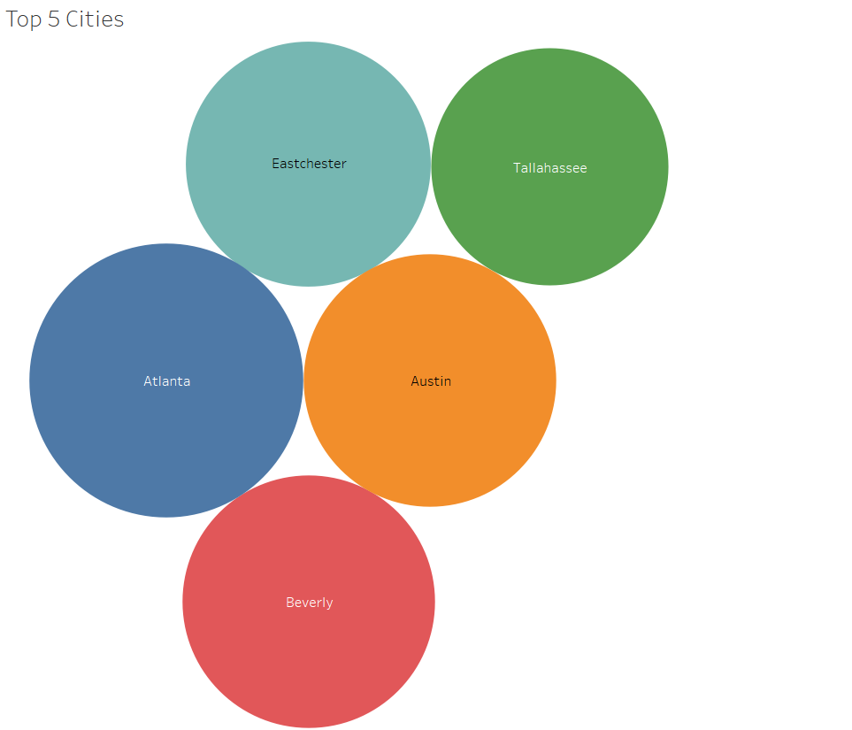

* Job Distribution by Company: the top 5 companies with the most job postings are:
  + Tata Consultancy Services: 4,680 jobs
  + Dice: 3,330 jobs
  + NR Consulting: 2,250 jobs
  + Stellent IT: 2,250 jobs
  + Robert Half: 1,710 jobs

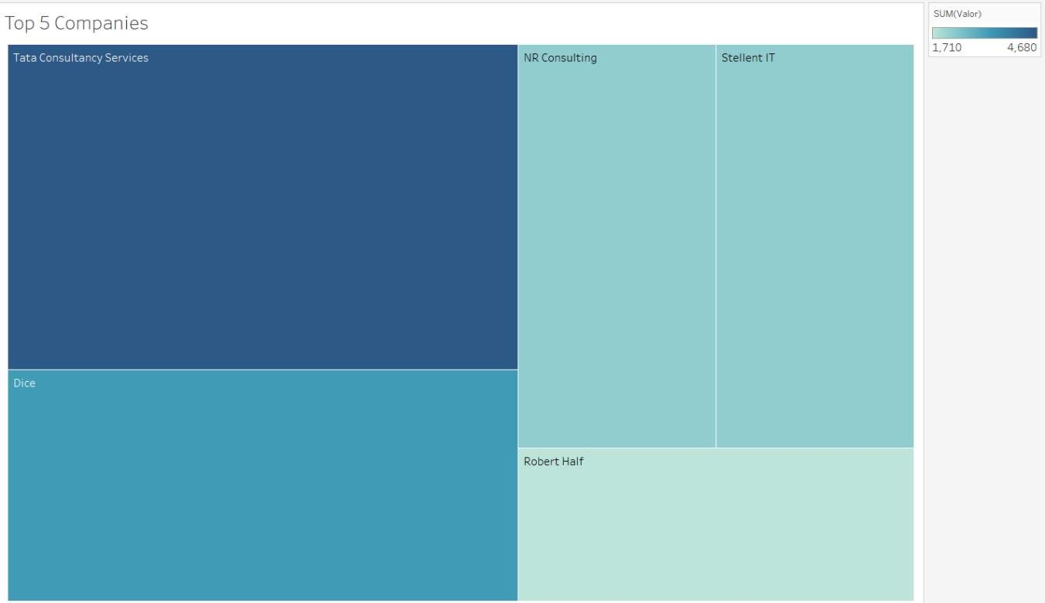

### Appendix B.5 | Data Quality Analysis

In evaluating the data quality, I conducted a comprehensive analysis at both the dataset level and the individual variable level. This process is crucial to pinpoint any potential issues, assess whether they can be resolved, and determine how data quality might affect the validity and trustworthiness of the results.

* Volume Check (Post-Filtering): after implementing the necessary filtering steps, the dataset was reduced to 756 rows and 11 columns, indicating a substantial reduction in volume. This reduction suggests that non-essential or low-quality data were effectively removed, resulting in a more reliable dataset for analysis. The remaining columns predominantly contain string data rather than numerical values. The dataset was tested against the CRAPP test, which it passed successfully, confirming its reliability. This conclusion is further supported by the bibliographic analysis.
* Variable Level Analysis: since the dataset consists entirely of string values, traditional outlier detection methods, usually applied to numerical data, were not applicable. Consequently, no outliers were identified. The absence of numerical data means the risk of skewed results due to outliers is minimal, which enhances the trustworthiness of the analysis.
* Missing Value Analysis: to ensure the completeness of the data, I used KNIME to filter and analyse missing values through a column filter and an unpivot node. Across the three datasets, a total of 44 entries were found to be missing.
  + Proportion of Missing Data: The missing data represents a certain proportion of the overall dataset, which needs to be considered when interpreting the results. It's important to assess whether these missing values are randomly distributed or follow specific patterns, as this can significantly influence the conclusions drawn from the analysis.
  + Impact on Data Quality: The presence of missing data can affect the overall data quality, potentially impacting the validity of the results. By identifying the proportion and pattern of missing data, appropriate steps can be taken to minimise any negative impact.

The data quality analysis at both the dataset and variable levels shows that, while the dataset has been filtered to improve its reliability, attention must be given to the identified missing data. Understanding the extent and distribution of these missing values will help ensure that the analysis remains valid and trustworthy.

## APPENDIX C | Aniket

### Appendix C.1 | Bibliography

The appendix contains data and deliverables based on the evaluation of sources that define the theory of CRAAP as well as CRAAP Test conducted on 2 sources that are relevant to our general scenario.

CRAAP TEST - Understanding

CRAAP test is a methodology used to analyse and define the overall quality of a data source. The 5 major pillars of CRAAP are: - Currency; Relevance; Authority; Accuracy and Purpose. I have analysed two sources to gain a better insight into the topic. One source is dedicated to use of CRAAP Test in the modern digital world which will help us analyze the changing metrics of the current age and trends whereas the other source is using CRAAP Test in the context of the healthcare industry which helps us understand the methodology by relating it with an example.

Currency

Currency is the relevancy of a dataset with respect to the timeliness of the information in discussion and if the information is still true and relevant to the topic to be analysed. The complexity of currency and the analysis of data for currency has increased and is forecasted to get more complex in the future because of the increasing sources of information and at the pace of this information being produced. (Sye & Thompson, 2023)

Relevance

Relevance is the pillar which considers whether the information in discussion or review is related to the topic of our research or analysis and how this set of information meets our exact requirements and adds to the understanding of the analysis or research. The main question an analyst should consider while assessing the relevancy of any information or dataset is if this information will add value to the specific analysis or argument they are working on. Relevance in today’s world has become a little subjective because of the vast and diverse needs of the users. (Sye & Thompson, 2023) For example, a doctor will need relevant information to provide the best possible and prompt treatment for their patient whereas irrelevant information can result in delayed prognosis and treatment of a certain patient. (Chalkley, 2024)

Authority

Authority is the pillar of CRAAP Test that assesses the credibility of the author of the given source of information or data. It assesses the authority on some metrics of the author like qualifications, expertise, experience and affiliations to analyses the authority of the given source. Authority has been becoming a little difficult to analyze and is being questioned in the digital age because of various platforms offering self-publishing as well as platforms like social media which makes the analysis of real expertise and opinion difficult. (Sye & Thompson, 2023) In the healthcare industry information coming from authoritative sources is a crucial aspect, as relying on opinions of non-authoritative sources can lead to serious incidents and consequences. (Chalkley, 2024)

Accuracy

Accuracy assesses the overall correctness, reliability and truthfulness of the source by analyzing whether the information has been supported or backed by relevant evidence and justification. Accuracy of a source can be assessed by checking if the source has been peer-reviewed by relevant authorities or if the source has been verified by experts or not. Another aspect that can be used to assess the accuracy of a source is if the source is free from any type of errors and bias. A common way of building accuracy of a source is to cross-reference other reliable sources. Sye and Thomson stated that accuracy should be analysed in accordance with transparency of the source as sources can depict correct information but might miss relevant context to support the facts. In the context of healthcare industry accuracy is a crucial aspect as hinderance with the accuracy of data can lead to misunderstanding which can again lead to major mis happenings. (Chalkley, 2024)

Purpose

The fifth pillar of CRAAP Test is purpose which assesses why the information or source of information exists. It analyses the intent of the source and helps determine the motive of the information like selling, provoking, entertaining and other such metrics that can influence the content and understanding of the source. The analysis of purpose in the modern digital age has become difficult as a certain source can serve multiple purposes and understanding which makes it difficult to point out the exact intent and purpose of the source. (Sye & Thompson, 2023) Chalkley, also discusses that the purpose of a source helps users understand the underlying biases especially in cases of persuasion and selling as these sources might not portray the main objective information.

By analysing both the sources I can see how important and crucial CRAAP Test can be in analysing a source of data. I also got a good insight into the changing metrics and considerations with respect to the modern digital world as well as the practical implications of all the five pillars.

References

Chalkley, A. (2024). Making the most of libraries, Part 5: Evaluating information using the

CRAAP test. *British Journal of Healthcare Assistants*, *18*(7), 284-286. <https://doi.org/10.12968/bjha.2024.18.7.284>

Sye, D., & Thompson, D. (2023). Tools, tests, and checklists: The evolution and future of

source evaluation frameworks. *Journal of New Librarianship*, *8*(1), 76-100. <https://doi.org/10.33011/newlibs/13/9>

CRAAP Test of 2 Sources

Source 1

Harris, A., & Clark, C. (2023). Understanding the diffusion of business analysis

responsibilities. *Journal of Computer Information Systems*, *64*(2), 278-288. <https://doi.org/10.1080/08874417.2023.2193964>

|  |  |
| --- | --- |
| Currency | The data has been published online on 4th of December 2023 and printed publication on 3rd March 2024 which makes the data very relevant and helps us analyze the recent trends of the business analysis roles. |
| Relevance | The information is directed towards professionals in the business analysis industry as well as academic sectors that can benefit from the given data source which gives us an understanding of the business analysis roles and their metrics. |
| Authority | The given publication has been published in the Journal of Computer Information Systems which is an affiliated journal of International Association for Computer Information Systems. The editorial board of the journal is also experienced people hence makes the source of good authority. |
| Accuracy | The source of the data has been cross-referenced from various scholarly articles and journal and all the data is supported by the analytical data and excels which have been provided with the data for self-understanding and even checking the accuracy of the data. |
| Purpose | The purpose of the source is to analyze the main skills required by business analysts with respect to occurrence of job postings. |

Source 2

Kobets, V., Yatsenko, V., & Buiak, L. (2021). Bridging business analysts competence gaps:

Labor market needs versus education standards. *Communications in Computer and Information Science*, 22-45. <https://doi.org/10.1007/978-3-030-77592-6_2>

|  |  |
| --- | --- |
| Currency | The source has been derived from ICTERI 2020 conference held in 2020. The source was first available online 22nd of May 2021 which makes the data quite relevant and helps us analyze the skillsets required for business analyst roles. |
| Relevance | The source is relevant for academics, researchers and people working in the ICT field that are looking for data and insights on the skills and education related metrics of a business analyst role. |
| Authority | The source has been recognized by various experts of the industry and published by Springer Nature which is also a recognized and prestigious publisher. The ICTERI conference chooses its members by a very selective process which makes the authority of the dataset very strong and specialized. |
| Accuracy | The source has been derived from the conference proceedings which depicts the final discussion, the research paper also includes data from various research papers. The document is peer-reviewed which further enhances the accuracy of this source. |
| Purpose | The purpose of the source is to analyze search findings based on the educational and skill requirements of the business analyst industry. The source can be used for academic and professional purposes. |

### Appendix C.2 | Mind Map

The mind map was constructed after conducting the CRAAP Test and understanding the basic crux of the general scenario of the assignment in accordance with the initial group discussion on the proposed scope of analyzing Business Analyst role in the United States.

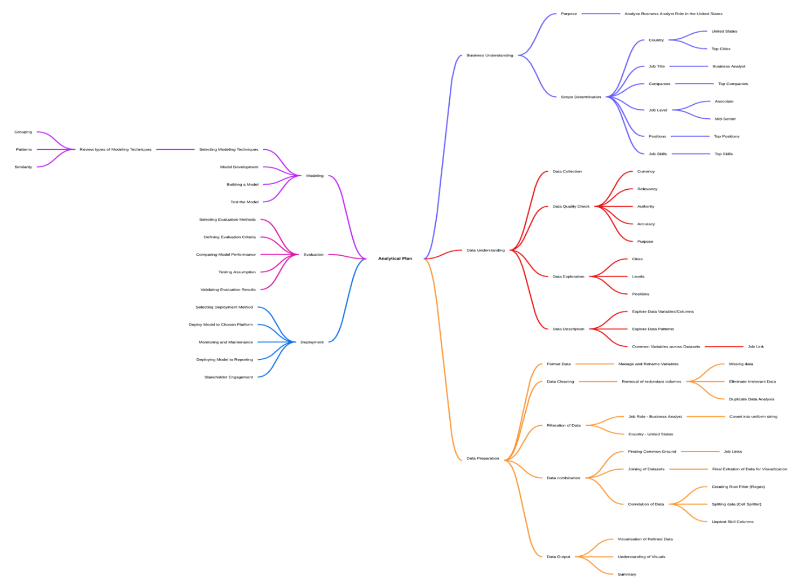

### Appendix C.3 | Data Understanding

The data used for this analysis focuses on various aspects of job postings that have been extracted from LinkedIn. The scope of our analysis was to analyze the job postings from United States particularly with respect to Business Analyst role. We saw that there are some key columns that will help us refine the dataset for our analysis.

From our understanding of the data Country, Job Title, Job Links and Job Skills are some very crucial aspects to justify our analysis and come up with the desired analytical metrics and co-relations.

Country – The country was an initial determinant in the scope. Our scope includes analyzing the United States job listings and the country variable will help us refine the data.

Job Title – The job title will help us refine the job listing to just that of Business Analyst roles to work on the exact data.

Job Links – The job links is the only variable that is present in all the datasets and will act as a joining metric for joining the datasets.

Job Skills – The job skills will help us analyze the various skills required for different types and positions of job listings.

Data Dictionary

|  |  |
| --- | --- |
| Job Links | |
| Definition | The link of the job listing extracted from LinkedIn. |
| Justification | The job link identifies the specific job posting on LinkedIn. |
| Guidelines for Use | Used to track and relate specific job postings. |
| Source | Extracted from LinkedIn |
| Type | String (URL) |

|  |  |
| --- | --- |
| Job Skills | |
| Definition | The link of the job listing extracted from LinkedIn. |
| Justification | The job link identifies the specific job posting on LinkedIn. |
| Guidelines for Use | Used to track and relate specific job postings. |
| Source | Extracted from LinkedIn |
| Type | String (URL) |

|  |  |
| --- | --- |
| Job Summary | |
| Definition | The summary of the job description provided by the company. |
| Justification | The job summary provides a brief overview of the job related to experience and responsibilities. |
| Guidelines for Use | Used to understand the expectations associated with the job. |
| Source | Extracted from LinkedIn |
| Type | String (Text) |

|  |  |
| --- | --- |
| Job Title | |
| Definition | The title or designation of the job. |
| Justification | The job title provides an understanding of the job role being offered or advertised. |
| Guidelines for Use | Used to understand the job role being offered. |
| Source | Extracted from LinkedIn |
| Type | String (Text) |

|  |  |
| --- | --- |
| Job Company | |
| Definition | The company that is offering the job. |
| Justification | The job title provides insight into the provider or advertiser of the job. |
| Guidelines for Use | Used to get data targeted from a particular company. |
| Source | Extracted from LinkedIn |
| Type | String (Text) |

|  |  |
| --- | --- |
| Job Location | |
| Definition | The location where the job role is being offered. |
| Justification | The job title informs about the exact location of the job. |
| Guidelines for Use | Used to get geographically targeted data. |
| Source | Extracted from LinkedIn |
| Type | String (Text) |

|  |  |
| --- | --- |
| Job City | |
| Definition | The city where the job role is being offered. |
| Justification | The job city informs about the city where the job is being offered. |
| Guidelines for Use | Used to get geographically targeted data based on the city. |
| Source | Extracted from LinkedIn |
| Type | String (Text) |

|  |  |
| --- | --- |
| Job Country | |
| Definition | The country where the job role is being offered. |
| Justification | The job country informs about the country in which the job is being offered. |
| Guidelines for Use | Used to get geographically targeted data based on the whole country. |
| Source | Extracted from LinkedIn |
| Type | String (Text) |

|  |  |
| --- | --- |
| Job Position | |
| Definition | The position being offered with the job. |
| Justification | The job position informs about the position of the job being offered or advertised. |
| Guidelines for Use | Used to get targeted data for a specific position. |
| Source | Extracted from LinkedIn |
| Type | String (Text) |

|  |  |
| --- | --- |
| Job Position | |
| Definition | The position being offered with the job. |
| Justification | The job position informs about the position of the job being offered or advertised. |
| Guidelines for Use | Used to get targeted data for a specific position. |
| Source | Extracted from LinkedIn |
| Type | String (Text) |

|  |  |
| --- | --- |
| Job Level | |
| Definition | The level or seniority of the job being offered. |
| Justification | The job level informs about the level or seniority of the job listing. |
| Guidelines for Use | Used to target people of relevant experience. |
| Source | Extracted from LinkedIn |
| Type | String (Text) |

|  |  |
| --- | --- |
| Job Type | |
| Definition | The type of working mode the job is offering. |
| Justification | The job type informs about the mode of employment like onsite and offsite. |
| Guidelines for Use | Used to target jobs with preferred modes. |
| Source | Extracted from LinkedIn |
| Type | String (Text) |

The various variables of the data dictionary have been derived after cleaning the data which are discussed in the following part of the report which talks about the detailed and what a vital role the Job Links played in linking the 3 datasets.

### Appendix C.4 | Result of Analysis (Data Preparation)

The data preparation section consists of various metrics of our analytical plan including explanation on the data cleaning, filtration and the resulting findings which have been further visualized and summarized for better understanding.

KNIME Workflow

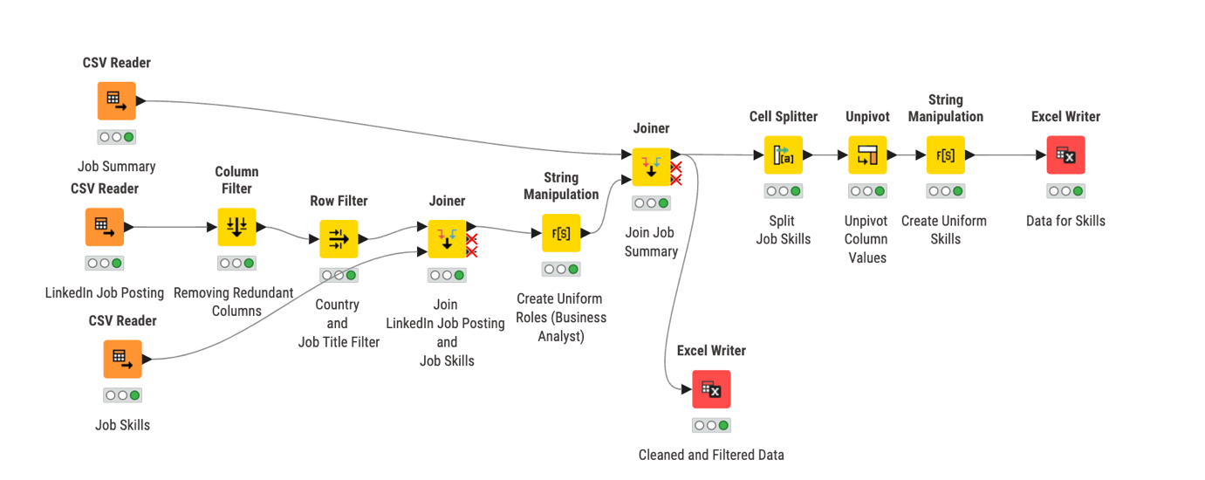

Data Cleaning

The source of our analysis consisted of 3 different datasets, the common variable in all the 3 datasets was Job Links which was then used to link and combine all three datasets using KNIME.

Appendix C.5.1.1 | Removing Redundant Columns

KNIME was used for all the cleaning and filtration of the given datasets for which the workflow has been attached above. The first step to clean the data is to remove all the redundant columns which present no value to our analysis. An analysis of all the columns was also done to analyze to recognize any data types and if any node can be applied to define a data type for further analysis but all the filtered columns to be used for the analysis were strings.

Appendix C.5.1.2 | Joining Datasets

Now I had all the individual datasets without the redundant columns. I then analysed the common links between the 3 datasets which was the job links. I used the job link as a common point and joined 2 datasets at a time. The final output was a common table which had all the cleaned data.

Appendix C.5.1.3 | Refining Column Names/Variables

After joining the datasets, I landed with the final table for us to start working on our analysis based on the scope of the analytical plan, but all the column names were not exactly appropriate and understandable. I renamed all the column names with respect to the relevant data they contained for better understanding. The output table was used to create the data dictionary and to document all the various variables for working on filtration and refining of the data.

Appendix C.5.2. | Data Filtration

For the filtration of the cleaned data, I revisited the scope of our analysis because relevant filters and metrics were needed to be added on KNIME to come up with a further refined table.

Filtration in accordance with Analysis Scope

The scope of our analysis was confined to Business Analyst roles in United States, row filters were applied on Job Titles and Job Country to filter data that was relevant for our scope of analysis. The resulting table had 3 unique values in the Job Titles because of difference in the capitalization of strings which was rectified by using string manipulation to replace all the values with one unique value. This data was then extracted in excel format to perform analysis and visualisations of the job market and their relevant metrics.

Data After Initial Extraction (After refining according to Scope)

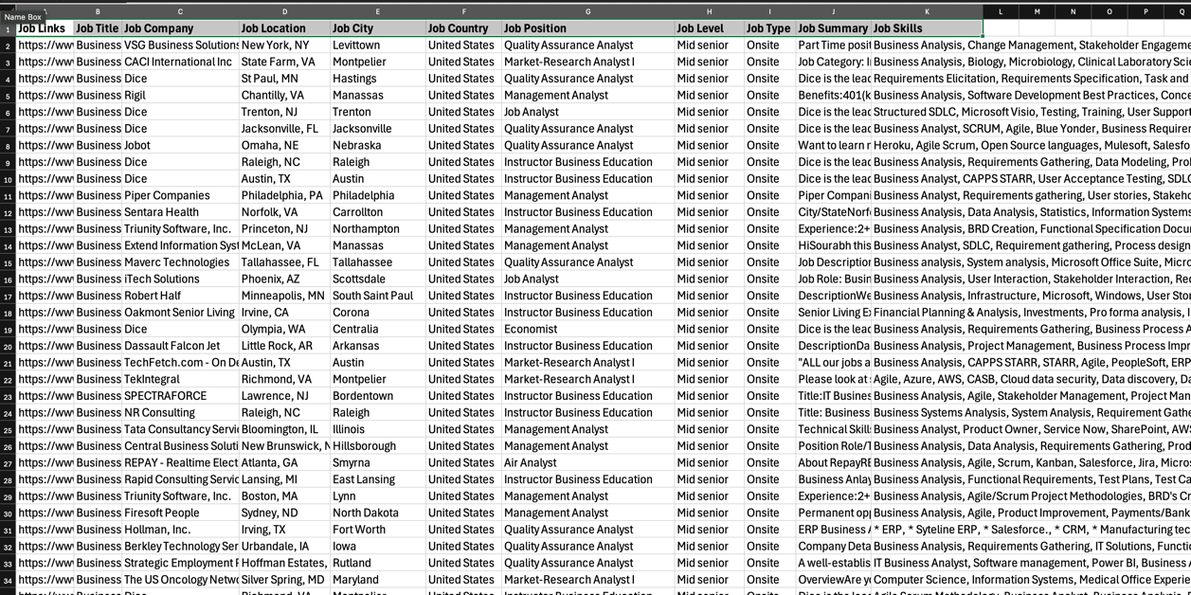

Filtration and Conversion of Job Skills

The Job Skills variable of our filtered data was in the form of a continuous string but had different values that needed to be split into different fields. I used KNIME to split the strings into columns which were then unpivoted into one column and linked to the relevant variables.

These functions resulted in giving us the exact analysis of skills but led to repetition of all the other variables/column fields which in turn would not lead to the exact number of data being visualized to be correct. Hence, an excel extracted during this phase was then used to generate visuals with respect to the skills. Co-relation amongst all the variables/columns with respect to the job skills remained intact and relative to the true values.

The resulting skills had similar values that meant the same thing; to come up with more accurate results these skills were renamed to the string name which was repeated maximum times. For example – Communication and Communication Skills were converted to Communication.

Dataset After Cell Splitting and Unpivot – Used for Job Skills

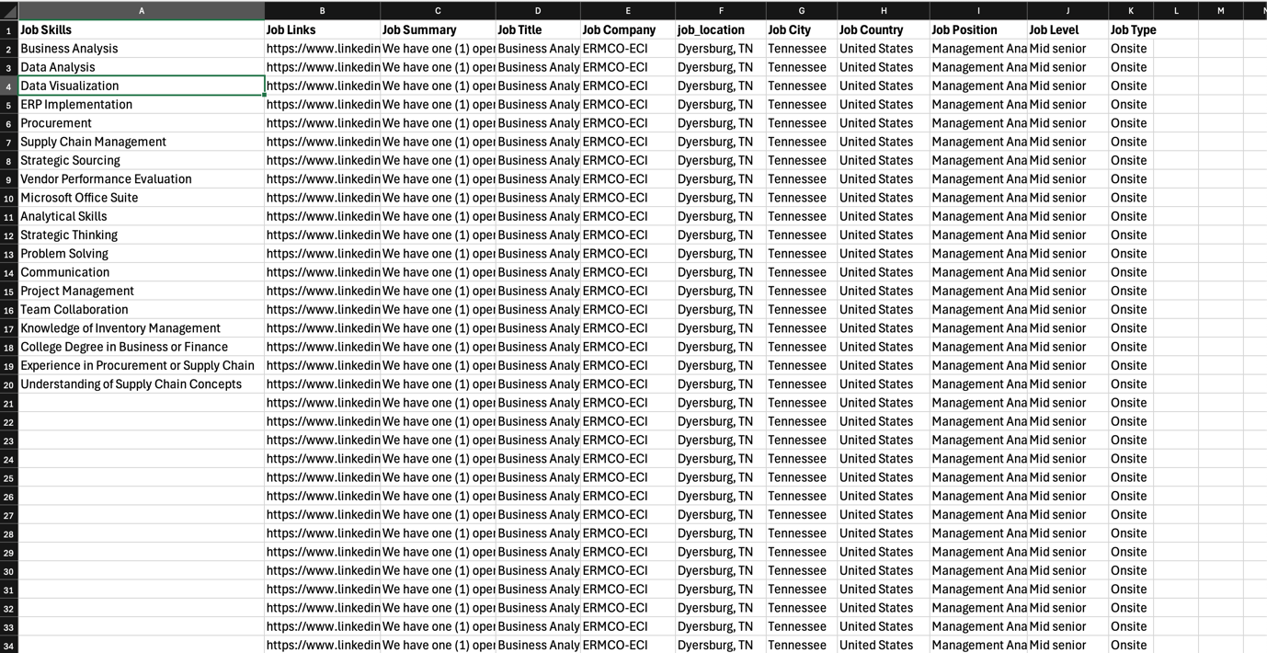

Visualisations and Description

The following visuals have been derived from the excels extracted after all the filtration and conversion of data mentioned above which gives us insight on the data being discovered and analysed for this analytical plan.

Visual 1 – Total Jobs in United States



Visual 1 show the total number of Business Analyst job offerings in the United States which comes out to be 761 after filtration of job titles and country.

Visual 2 – Top 5 Cities and Job Levels



Visual 2 shows us the top 5 cities with respect to the density of jobs being offered in United States. The cities in the map and graph have been depicted with same colour for better understanding. We can also see the bifurcation of these jobs with respect to the job levels on the bottom right corner which tells us that there are more jobs for mid-senior job levels than that of associates.

Visual 3 – Top 5 Companies and Job Levels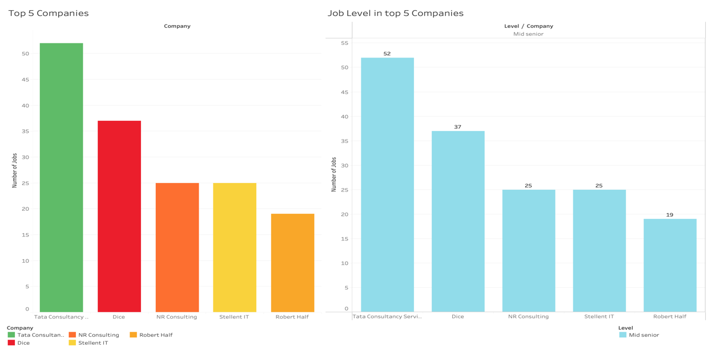

Visual 3 depicts the top 5 companies that are offering business analyst roles along with the level of jobs being offered by these companies. We concluded that these top 5 companies are only offering mid-senior jobs and no associate jobs which suggests there are no low-level job entries in the top 5 companies of United States.

Visual 4 – Top Companies in top 5 Cities

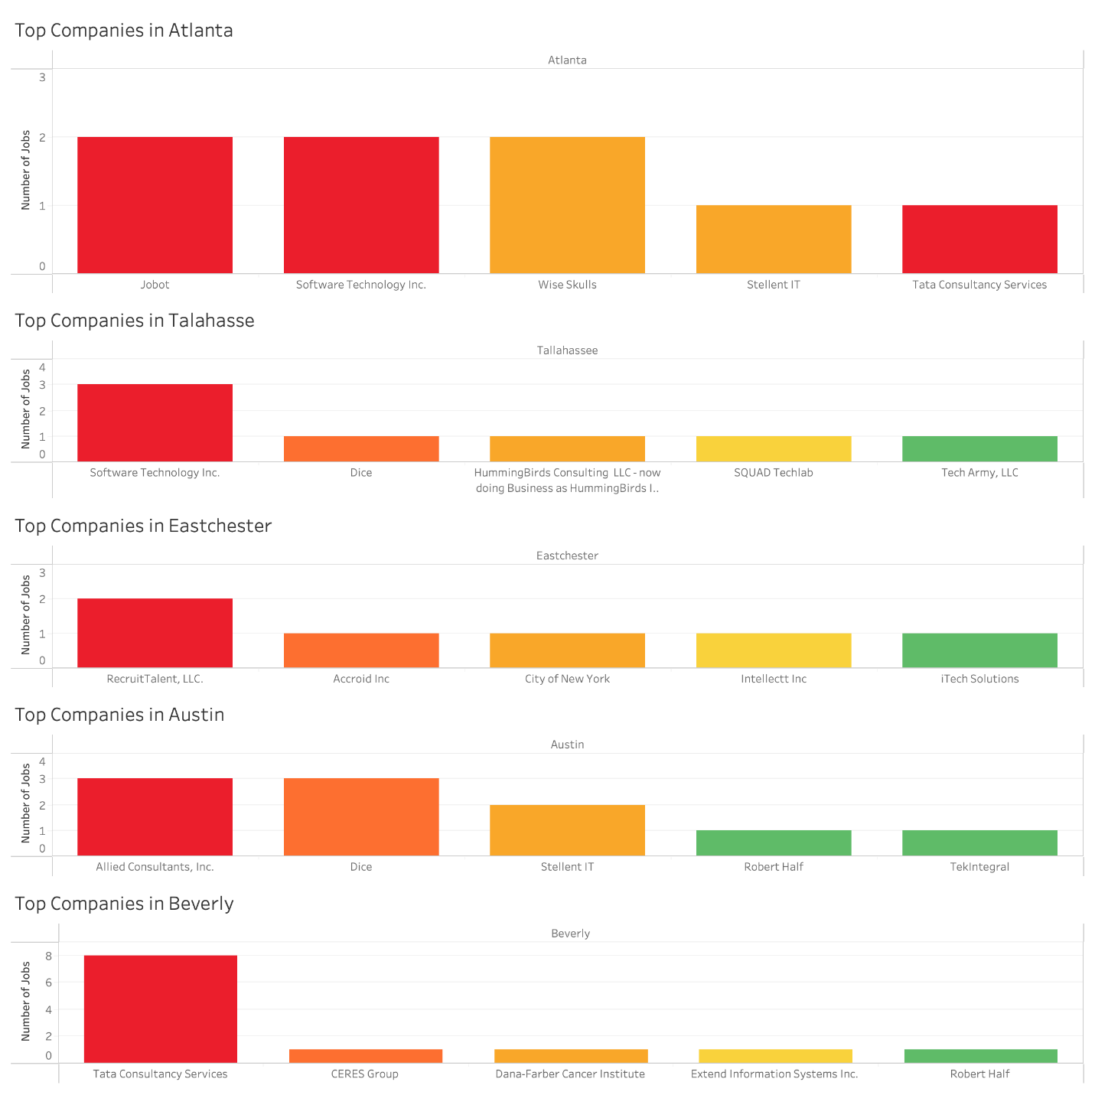

Visual 4 shows the top 5 cities with job offerings and the relevant top companies offering these jobs. We can see and analyze three common entities – Tata Consultancy Services, Dice and Robert Half amongst all the visuals which we saw in Visual 3.

Visual 5 – Total Jobs and Top 5 Positions

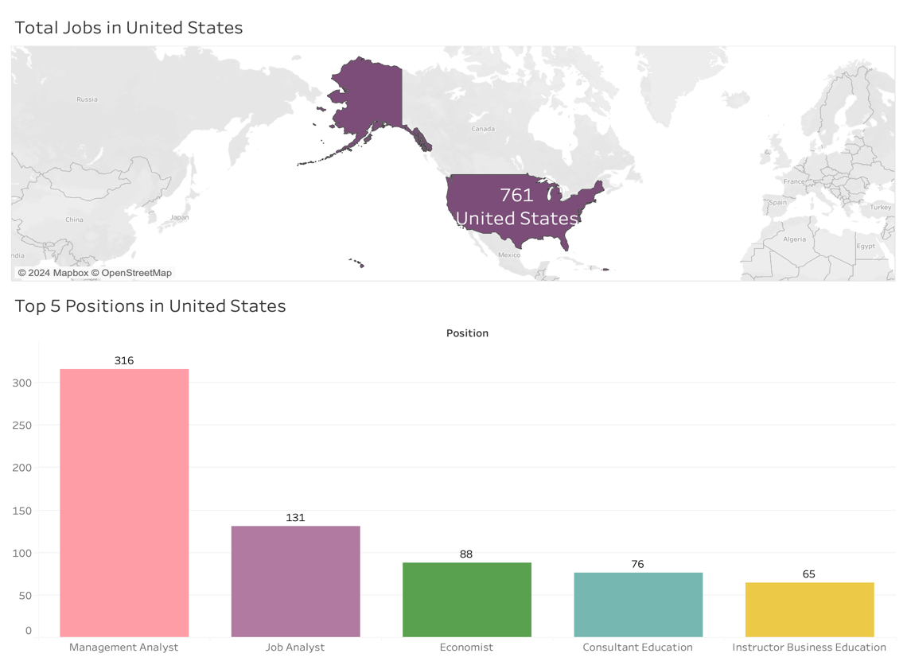

From Visual 5 we can see the top 5 positions that are being offered in the United States and their respect values. Management Analyst roles are the most abundantly offered roles in the country which accounts for more than 40% of the total jobs.

Visual 6 – Top 5 Companies and Respective Positions



Visual 6 depicts the top 5 companies and the various Positions being offered by this pool of companies, we have observed that some positions from the total distinct values of were not observed in this pool of positions. We can see that the maximum number of job position being offered is Management Analyst which further validates our findings of Visual 5.

Visual 7 – Top 10 Skills

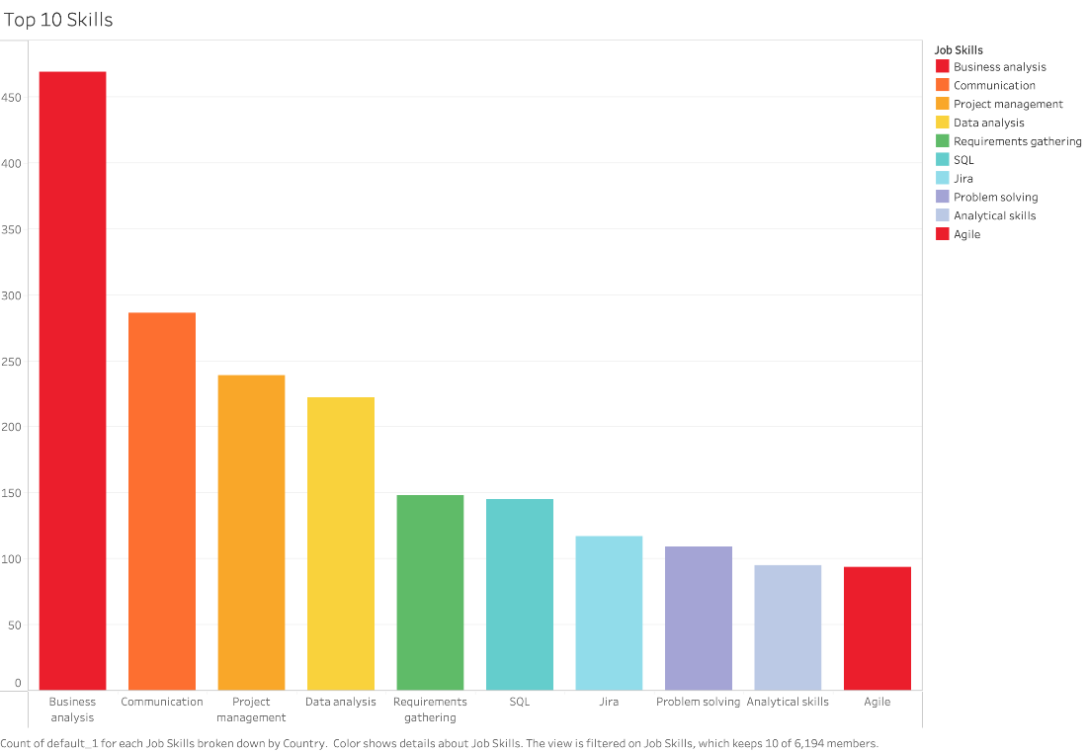

Visual 10 depicts and elaborates on the Top 10 skills that are in demand in the United States for Business Analyst roles. The most sought-after skill is Business Analysis.

Visual 8 – Top 10 Skiils with Respect to Top Companies



Visual 8 shows the top 10 skills required by the Top 5 companies we established in Visual 3. The data has been derived from the unpivoted data which had certain missing values too, but the result’s relative co-relation remains true to its value. The results from this visual also helps verify and support Visual 7.

Visual 9 – Top Skills required by top



Visual 9 gives an insight into the top 10 skills that are sought for the top 5 job positions being offered that were established in Visual 5. We can clearly see that the skill required the most is business analysis. The job skills follow a similar trend for the whole data where Business Analysis is the most sought-after skill.

### Appendix C.5 | Data Quality Analysis

The quality of the data is a very crucial aspect to analyze and assess if the results of the analysis conducted is true to its intended purpose. Our data that was used for analysis was a pool of 3 datasets derived from a common source – LinkedIn.

The 3 datasets had various complex fields of data, one particularly tricky part of the data till the current phase of analysis was Job Skills as the data field was in a string format but had multiple values. To tackle this problem cell splitting and unpivot function was used to analyze, visualize and summarize the data for job skills.

I used 2 data sets for the exploration of the current analysis which can also be seen in the data preparation part from my Knime workflow. The following statistics were derived from the 2 excels: -

Data After Initial Extraction

The first excel was used to create visuals and summarize all the data relevant to the Business Analyst role with respect to various metrics like top cities, job levels, job positions and other relevant co-relations. This table did not include the splitting of the job skills. We looked at the missing values and unique values to look at the correctness, completeness and uniqueness of the given data.

*Data Quality of Initial Refined Data*

|  |  |  |
| --- | --- | --- |
| Variable/Column Name | Missing Value | Unique Values |
| Job Links | 0 | 761 |
| Job Title | 0 | 1 |
| Job Company | 0 | 414 |
| Job Location | 0 | 330 |
| Job City | 0 | 242 |
| Job Country | 0 | 1 |
| Job Position | 0 | 23 |
| Job Level | 0 | 2 |
| Job Type | 0 | 1 |
| Job Summary | 0 | 717 |
| Job Skills | 0 | 760 |

After analysing the given table and the overall dataset we can evaluate data quality metrics like completeness, consistency, accuracy, timelessness, uniqueness and validity of the given refined data.

|  |  |
| --- | --- |
| Completeness | The given data is complete as it doesn’t have any missing values. |
| Consistency | The data is consistent with definitive and relative values. |
| Accuracy | High accuracy can be observed as relative values of Job Links and Job Skills are close. |
| Timelessness | The data represents data extracted from LinkedIn and of the current year which makes the data timely and apt. |
| Uniqueness | The uniqueness is high which can be seen and depicted by the unique values. |
| Validity | Data is valid as all the columns/variables stay true to their values and intended use. |

Data After Job Skills Extraction

As mentioned earlier, the job skills in the dataset are in a combined string and cannot be assessed in this format. We had to tamper with the dataset to get results. We used cell splitter to split the string into multiple columns. These columns were then converted into one column using the unpivot function. This process of splitting the cells and unpivoting the cells has resulted in increasing the rows and in turn led to repetition of data as well as resulted in missing values in the unpivoted column of job skills. This has happened because the number of job skills are not uniform for each job listing.

The resulting excels had the following values of missing and unique values.

*Data Quality of Excel for Job Skills*

|  |  |  |
| --- | --- | --- |
| Variable/Column Name | Missing Value | Unique Values |
| Job Link | 0 | 761 |
| Job Title | 0 | 1 |
| Job Company | 0 | 414 |
| Job Location | 0 | 330 |
| Job City | 0 | 242 |
| Job Country | 0 | 1 |
| Job Position | 0 | 23 |
| Job Level | 0 | 2 |
| Job Type | 0 | 1 |
| Job Summary | 0 | 717 |
| Job Skills | 52273 | 6859 |

As we conducted analysis of data quality of the initial data, similar analysis can be done for the refined table for job skills.

|  |  |
| --- | --- |
| Completeness | The completeness of the data has been hindered because of high missing values in the Job Skills variable/column. |
| Consistency | The consistency of data has been hindered because of repetition of data fields that happened after unpivoting. |
| Accuracy | Relevantly low accuracy because of the repeated values but relatives' values can be analysed. |
| Timelessness | The data represents data extracted from LinkedIn and of the current year which makes the data timely and apt. |
| Uniqueness | The uniqueness of the data is considerably low as there is numerous repetitions of data which can be clearly observed in the Job Skills column. |
| Validity | Data is relatively lowered because of repetition of the data. |

The occurrence of these missing values and the repetition of data can result in variations of the overall analysis of the results as well as visuals which in turn makes the data a little uncertain. The resulting co-relations have somewhat remained true to their value, but the relevance is not exactly accurate.

## APPENDIX D | Ethan Nien - nieyy007

### Appendix D.1 | Bibliography

CRAAP Test 1

Schröer, C., Kruse, F., & Gómez, J. M. (2021). A systematic literature review on applying CRISP-DM process model. *Procedia Computer Science*, *181*, 526-534. <https://doi.org/10.1016/j.procs.2021.01.199>

|  |  |
| --- | --- |
| Criteria | Evaluation |
| Currency | This research was published in 2021, only 3 years ago, and demonstrates the study of the CRISP-DM model during the 2 decades after its release, revealing the key research on contemporary issues in data visualisation and analysis planning in recent years. |
| Relevance | The systematic review is directly relevant to the work of finishing an analytic plan and implementing data visualisation. It covers how CRISP-DM is applied across various domains, offering insights into best practices that align with structured data analysis and visualisation requirements. The focus on each phase of the CRISP-DM model ensures that the content supports comprehensive analytic planning. |
| Authority | This article is published in a reputable academic journal, Procedia Computer Science, a respected journal under Elsevier, known for its thorough peer-review process and its role in disseminating high-quality research in computer science. Meanwhile, the research's credibility is further enhanced by the authors' connections with prestigious academic institutions. |
| Accuracy | The content of this reference is well-aligned with the practical application of data visualisation and analytic planning. It accurately reflects current industry practices and research trends, particularly in the implementation of CRISP-DM's phases. The systematic approach mentioned in the article can ensure the information is accurate and relevant, further, to be considered applied in data exploration work. |
| Purpose | The primary purpose of this review is to bridge the gap between academic research and practical application, particularly in the context of analytic planning and data visualisation. It aims to support researchers and scholars in effectively applying CRISP-DM to conduct data analysis with no apparent bias or conflict of interest, leading to a trustworthy reference for analytic planning and data visualisation. |

CRAAP Test 2

Qin, X., Luo, Y., Tang, N., & Li, G. (2020). Making data visualisation more efficient and effective: a survey. *The VLDB Journal, 29*(1), 93-117. <https://doi.org/10.1007/s00778-019-00588-3>

|  |  |
| --- | --- |
| Criteria | Evaluation |
| Currency | The research was published in 2020, the study is also recent and provides up-to-date information on the latest advancements in data visualisation techniques. The content reflects current practices and challenges in the field, making it relevant for contemporary analytic planning and data visualisation tasks. |
| Relevance | This reference discusses approaches aimed at increasing data visualisation's efficacy and efficiency. In the meantime, it covers a range of techniques and tools that meet the criteria of establishing and refining analytic plans, especially in the context of handling large datasets and creating scalable visualisations that can be directly applied in business analytics. |
| Authority | This article is published in the VLDB Journal, a reputable and well-established academic journal in the field of database management and data science. The joint authors, affiliated with Tsinghua University and the Qatar Computing Research Institute, bring significant expertise and credibility to the content, ensuring that the methodologies discussed are authoritative and well-founded. |
| Accuracy | The content of this reference is highly accurate, based on empirical research, and supported by numerous references to other authoritative studies. The techniques and recommendations for data visualisation are well-described, which makes them trustworthy and useful for creating and carrying out analytical plans. The survey's emphasis on scalability and efficiency directly supports the development of effective data visualisations for challenging tasks. |
| Purpose | The primary purpose of this reference is to provide a comprehensive survey of techniques that make data visualisation more efficient and effective. It aims to guide researchers and scholars in improving the visualisation process within analytic workflows, ensuring that the outcomes are both informative and actionable. The research is designed to inform and enhance practical applications in data visualisation, without obvious bias or conflict of interest. |

### Appendix D.2 | Mind Map

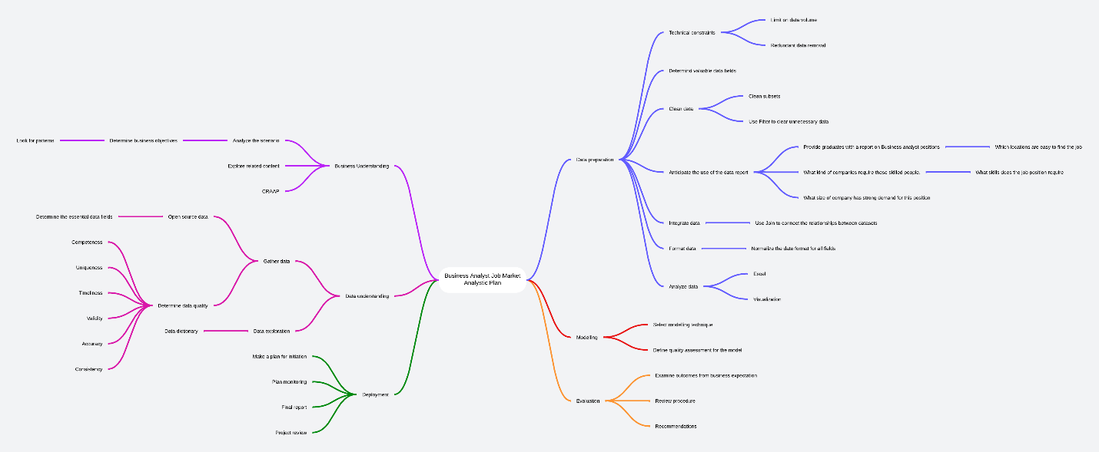

### Appendix D.3 | Data Understanding

The literature provided offers valuable insights for both analysis planning and the implementation of data visualisation and data preparation. The systematic review of the CRISP-DM process model highlights best practices across various phases, such as business understanding, data preparation, and modeling, which are crucial for structuring data-driven projects. For instance, emphasizing data preparation tasks like data selection, transformation, and cleaning is particularly relevant for ensuring data quality before visualisation. The literature also discusses the use of descriptive statistics and data visualisation techniques during the data understanding phase, which can enhance the clarity and interpretability of the data. Schröer et al. (2021) mentioned that descriptive statistics are the most significant technique for comprehending data. Further methods include interviewing experts, displaying sample data rows, and data visualisation. With the use of these techniques, data preparation and visualisation design can be made more effective and in line with a project's analytical objectives.

Given that the business objective of this report is clearly centered on the U.S. job market, the key data columns for analysis include company, job_title, job_skills, search_city, and job_level. These attributes are essential for understanding the dynamics of the job market, such as identifying key employers, the most sought-after skills, and geographic trends in job availability. Since the other data columns do not contribute to the analysis, they will be excluded from the subsequent stages to maintain focus and relevance. This streamlined approach ensures that the analysis remains targeted and efficient, focusing only on the most critical variables that align with the report's objectives. The following data dictionary tables show the main data attributes in the analytic plan.

Data Dictionary

|  |  |
| --- | --- |
|  | RowID |
| Definition | The unique identifier for each row. |
| Justification | To uniquely identify and track each job and the skill. |
| Guidelines for Use | Use to filter or reference specific rows in analysis. |
| Type | String (Text) |
| Source | A unique key for each row, is automatically generated by the visualisation system (KNIME) |
| Codeset | System Defined |

|  |  |
| --- | --- |
|  | job_ID |
| Definition | The unique identifier for each job. |
| Justification | To Uniquely identify and track each job |
| Guidelines for Use | Use to filter or reference specific jobs in analysis. |
| Type | String (Text) |
| Source | A unique key of the job, is automatically generated by the visualisation system (KNIME) |
| Codeset | System Defined |

|  |  |
| --- | --- |
|  | job_title |
| Definition | The title of the job position being advertised. |
| Justification | To categorize the nature of the job position. |
| Guidelines for Use | Use to categorize job postings by title for analysis or sorting. |
| Type | String (Text) |
| Source | linkedin_job_postings.csv  <https://www.kaggle.com/datasets/asaniczka/1-3m-linkedin-jobs-and-skills-2024> |
| Codeset | Not Applicable |

|  |  |
| --- | --- |
|  | company |
| Definition | Name of the company offering the job. |
| Justification | To identify the employer for the job posting. |
| Guidelines for Use | Use to group or filter job postings by company. |
| Type | String (Text) |
| Source | linkedin_job_postings.csv  <https://www.kaggle.com/datasets/asaniczka/1-3m-linkedin-jobs-and-skills-2024> |
| Codeset | Not Applicable |

|  |  |
| --- | --- |
|  | job_location |
| Definition | The actual location of the job including state and city. |
| Justification | To display the job location for users to review. |
| Guidelines for Use | Use to filter or analyze job listings by location. |
| Type | String (Text) |
| Source | linkedin_job_postings.csv  <https://www.kaggle.com/datasets/asaniczka/1-3m-linkedin-jobs-and-skills-2024> |
| Codeset | Not Applicable |

|  |  |
| --- | --- |
|  | search_city |
| Definition | The city where the job is searching for. |
| Justification | To specify the city of the job search is important for candidates who are looking for narrow-range location roles. |
| Guidelines for Use | Use to filter or analyze job postings based on search city. |
| Type | String (Text) |
| Source | linkedin_job_postings.csv  <https://www.kaggle.com/datasets/asaniczka/1-3m-linkedin-jobs-and-skills-2024> |
| Codeset | Not Applicable |

|  |  |
| --- | --- |
|  | search_country |
| Definition | The country where the job is searching for. |
| Justification | To specify the country of the job search is important for candidates who are looking for jobs based on nations. |
| Guidelines for Use | Use to filter or analyze job postings based on search country. |
| Type | String (Text) |
| Source | linkedin_job_postings.csv  <https://www.kaggle.com/datasets/asaniczka/1-3m-linkedin-jobs-and-skills-2024> |
| Codeset | Full country name |

|  |  |
| --- | --- |
|  | search_position |
| Definition | Unified job titles on Linkedin that companies are searching for. |
| Justification | Assist in grouping positions for further analysis. |
| Guidelines for Use | Use to categorize search results by job position. |
| Source | linkedin_job_postings.csv  <https://www.kaggle.com/datasets/asaniczka/1-3m-linkedin-jobs-and-skills-2024> |
| Codeset | Not Applicable |

|  |  |
| --- | --- |
|  | job_level |
| Definition | The level of the job position. |
| Justification | Use to filter or analyze jobs by level. |
| Guidelines for Use | To understand the experience or career level required for the job. |
| Type | String (Text) |
| Source | linkedin_job_postings.csv  <https://www.kaggle.com/datasets/asaniczka/1-3m-linkedin-jobs-and-skills-2024> |
| Codeset | |  | | --- | | Domain Description | | Associate | | Mid senior | |

|  |  |
| --- | --- |
|  | job_type |
| Definition | Type of the job. |
| Justification | Classify the work style for the job. |
| Guidelines for Use | Use to filter or analyze jobs by type. |
| Type | String (Text) |
| Source | linkedin_job_postings.csv  <https://www.kaggle.com/datasets/asaniczka/1-3m-linkedin-jobs-and-skills-2024> |
| Codeset | |  | | --- | | Domain Description | | Hybrid | | Onsite | | Remote | |

|  |  |
| --- | --- |
|  | job_skills |
| Definition | The skill required for the job. |
| Justification | To outline the competence needed for the job. |
| Guidelines for Use | Analyze the required skills and qualifications for the candidate. |
| Type | String (Text) |
| Source | job_skills.csv  <https://www.kaggle.com/datasets/asaniczka/1-3m-linkedin-jobs-and-skills-2024> |
| Codeset | Not Applicable |

|  |  |
| --- | --- |
|  | job_link |
| Definition | A URL link to the job posting on LinkedIn. |
| Justification | Provide a URL link enabling users to access further information for the job. |
| Guidelines for Use | Review the detailed job information by accessing the link. |
| Type | String (Text) |
| Source | linkedin_job_postings.csv  <https://www.kaggle.com/datasets/asaniczka/1-3m-linkedin-jobs-and-skills-2024> |
| Codeset | Not Applicable |

### Appendix D.4 | Data Preparation and Findings

The data source used in this report is up to 6.2GB, which, due to its large size, contains many data attributes and values that are not normalized. To address this, we adopt a method using the KNIME tool, where the job_link is considered the unique key for each row across the three datasets. This unique key serves as the basis for joining the data series. To ensure high-quality visual data analysis, a row filter is applied to exclude data with low analytical value, such as positions unrelated to business analysts, non-US locations, and duplicate columns. Additionally, the cell splitter is employed to divide job_skills that contain multiple skills separated by commas into individual skill fields, further enhancing the clarity and usability of the data for analysis.

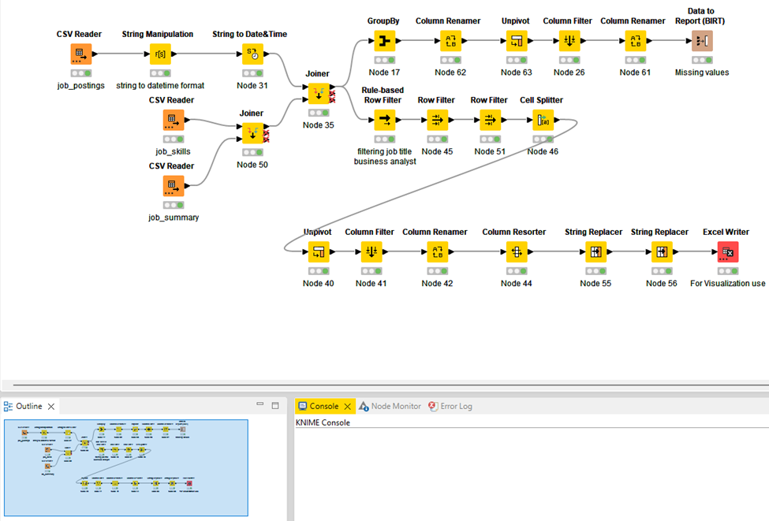

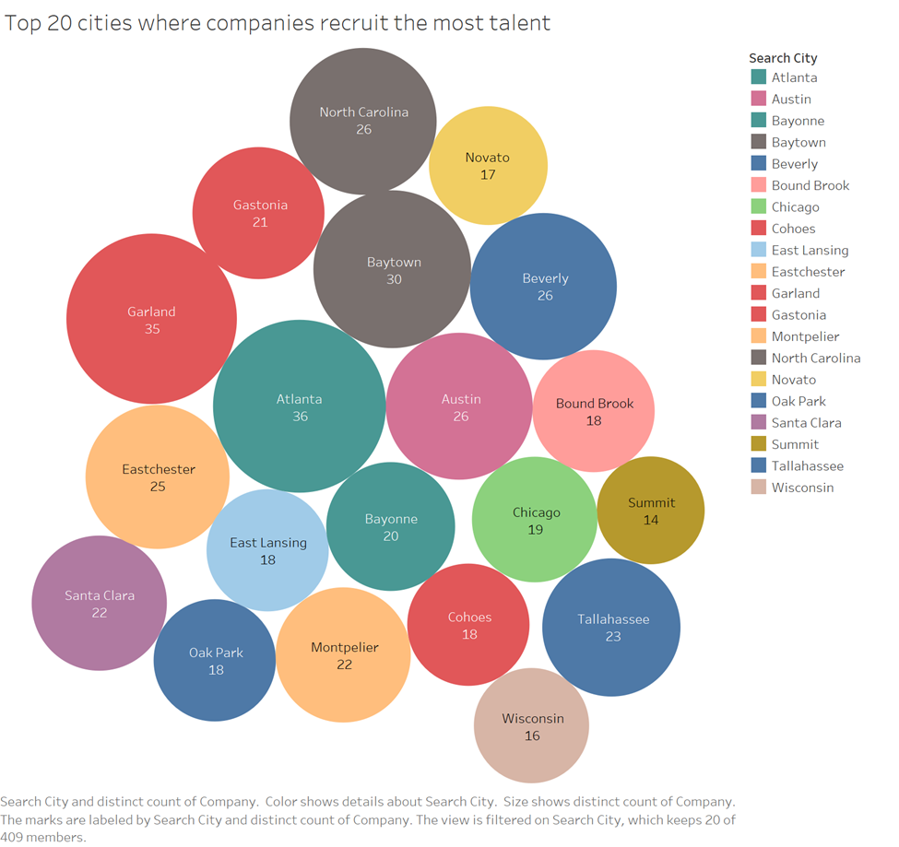

This graphic shows a bubble chart illustrating the top 20 cities where companies recruit the most in the United States. Each bubble represents a city, and the size of the bubble is proportional to the number of companies recruited by that city. Cities like Atlanta, Baytown, and Garland have the largest bubbles and express higher recruiting demands for business analysts’ talent.

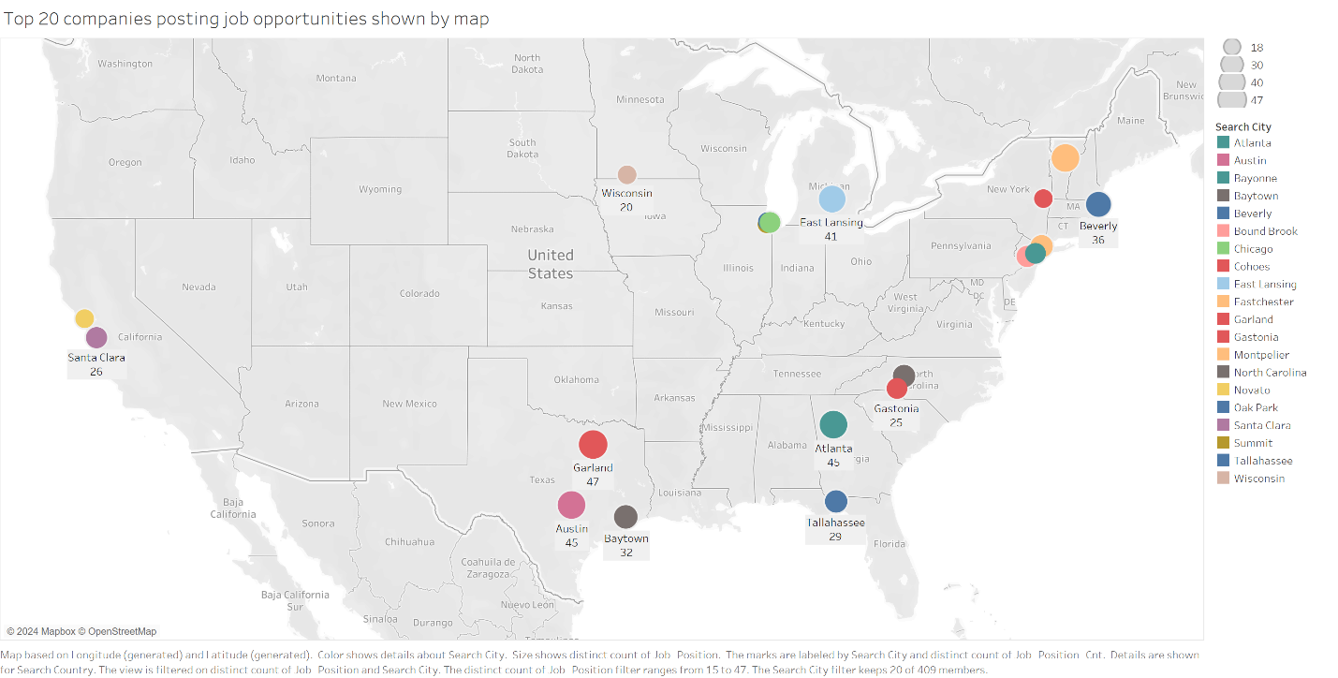The above image is a data visualisation on the map that highlights the top 20 cities where companies are posting job opportunities. The small cycles on the map represent multiple cities, and their size and colour correspond to the concentration of job posts from many different companies in these regions.

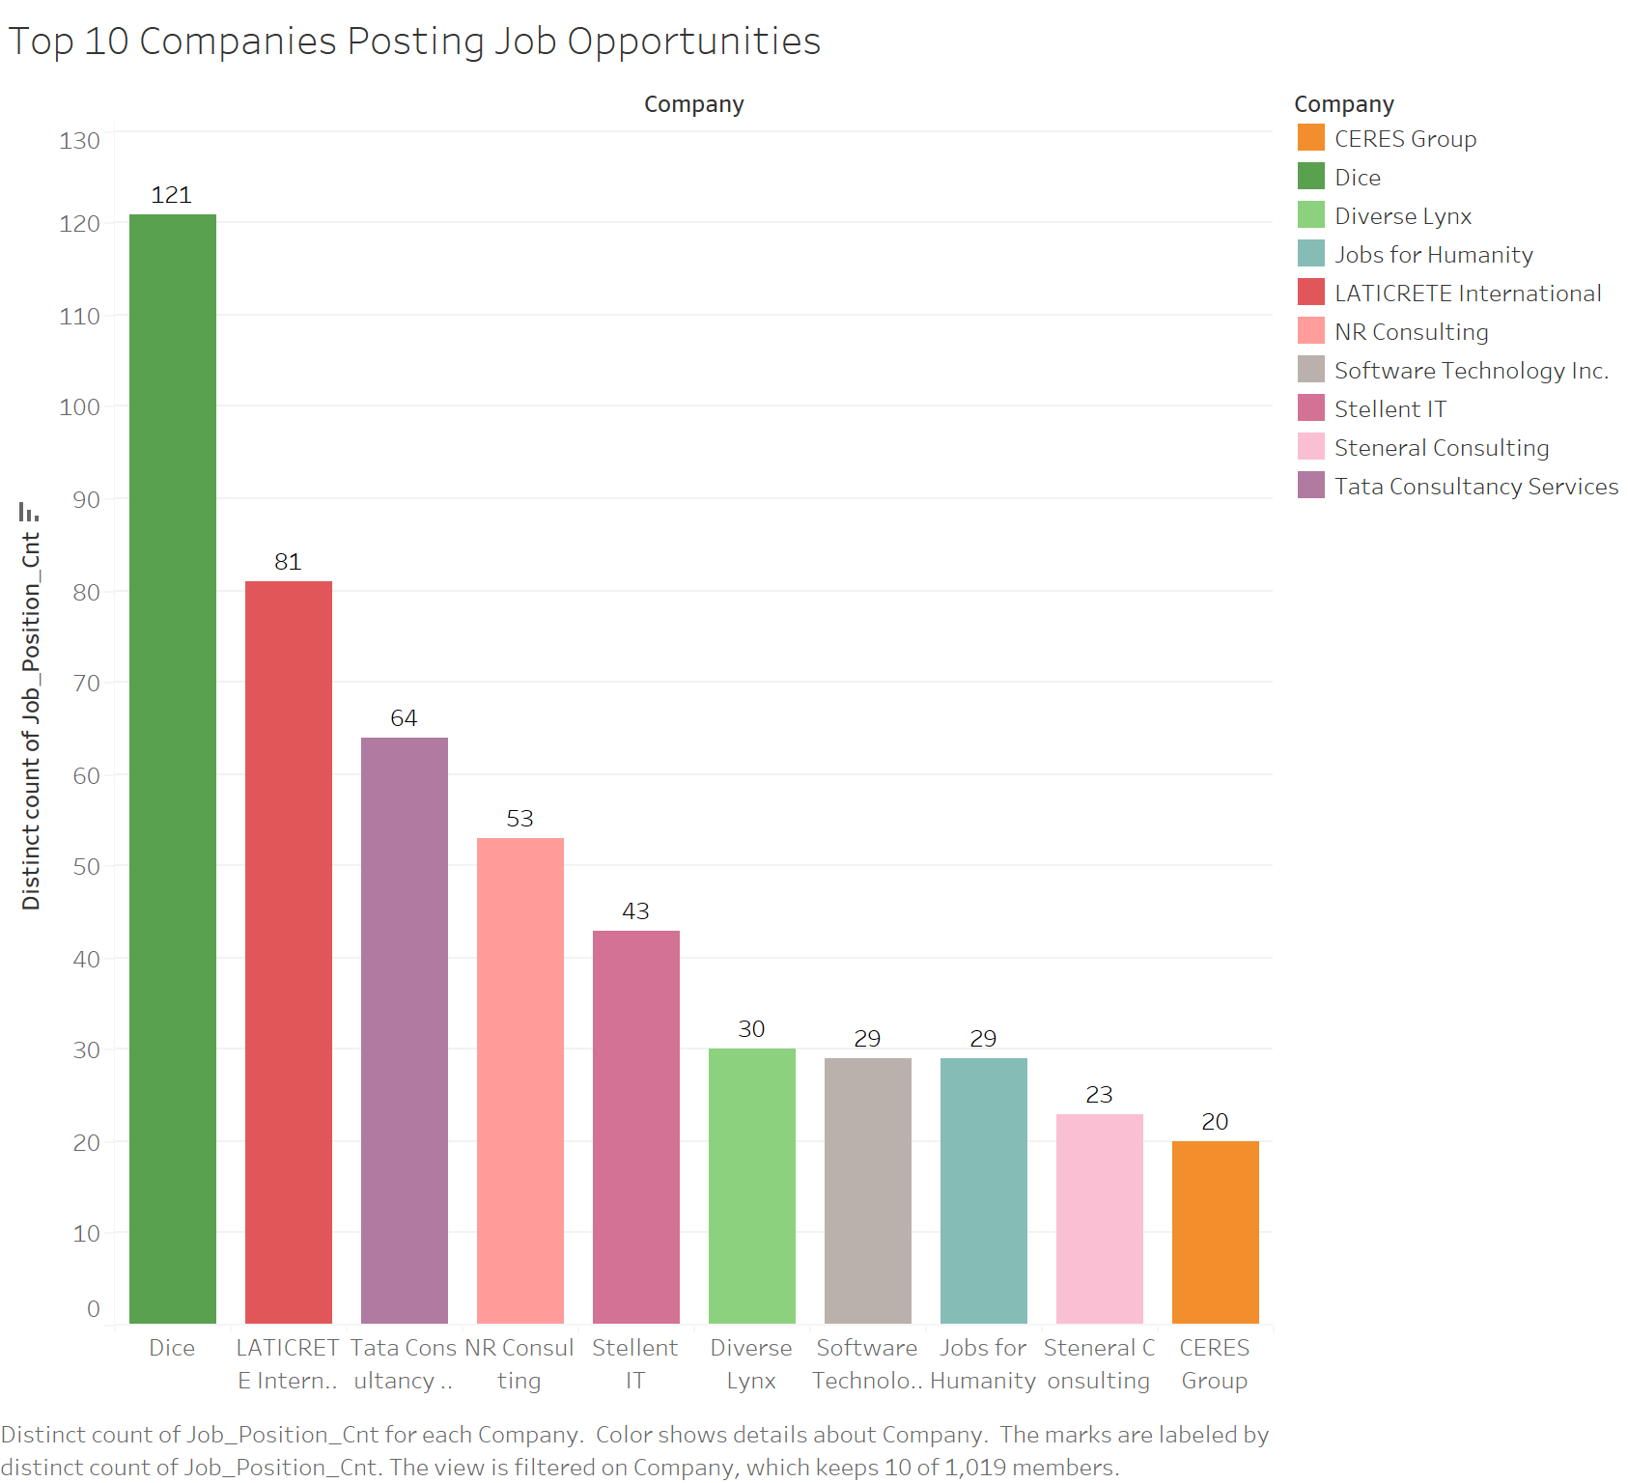The top 10 companies with the most job opportunities posted are displayed in this bar chart. Obviously, Dice is the company with the most job postings; Tata Consultancy Services and LATICRETE International are next. Each bar has a company-specific colour code.

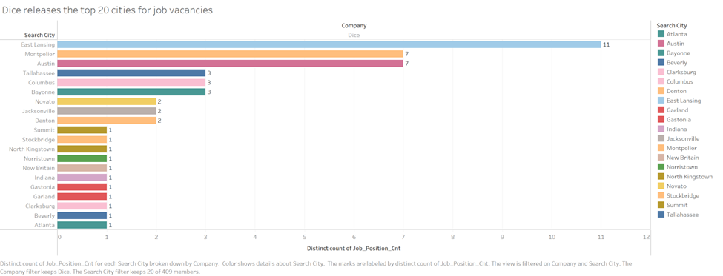

Following that, this report specifically focuses on analyzing Dice company, as the last diagram indicates that it posted the most job vacancies. The horizontal bar chart highlights the top 20 cities where Dice has the highest number of job vacancies. Among the top cities in Dice's job posting rankings are East Lansing and Montpelier.

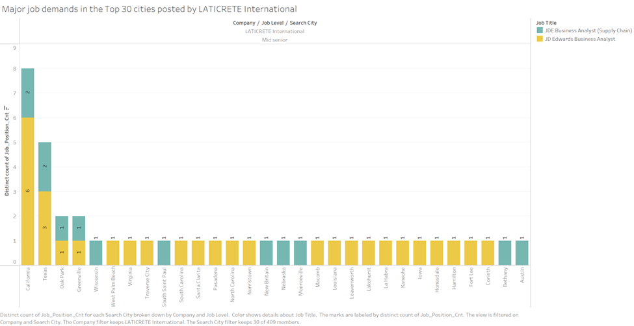This bar chart lists the main job requirements posted by LATICRETE International in the top 30 cities. The chart displays two job titles within the company in different cities, highlighting demand for positions such as JDE Business Analyst (Supply Chain) and JD Edwards Business Analyst.

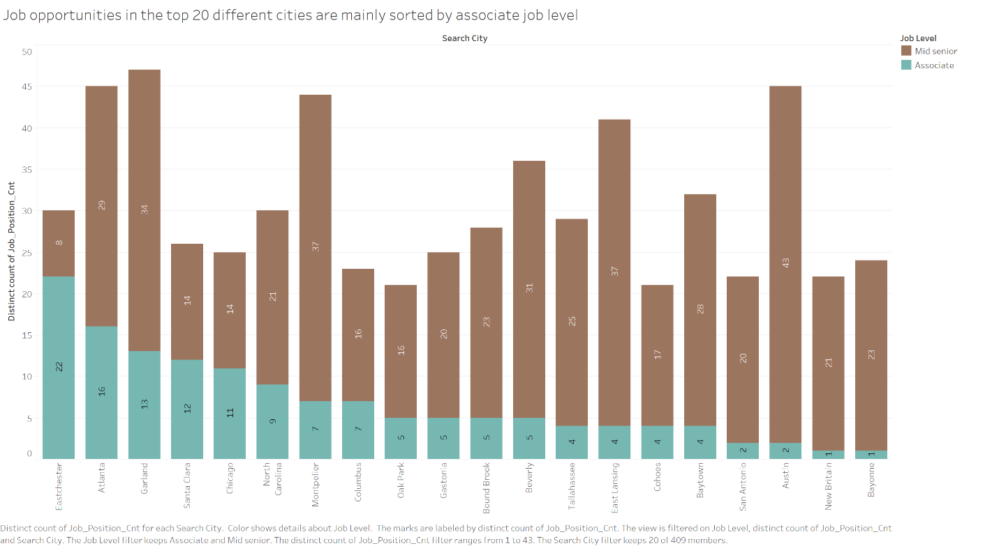The distribution of business analyst job opportunities across various cities is illustrated in this graph. It specifically makes a distinction between the Associate and Mid Senior levels. As the picture illustrates, the majority of opportunities are on the junior level in cities like Eastchester, Atlanta, and Garland. Likewise, there are still some associate posts available in some cities, such as Montpelier and East Lansing, even if the percentage of opportunities at the senior level is relatively high. Generally, the graph even provides graduates of business analysis majors some reference bases for target cities. Moreover, it is mainly sorted by the need for Associate positions in various cities.

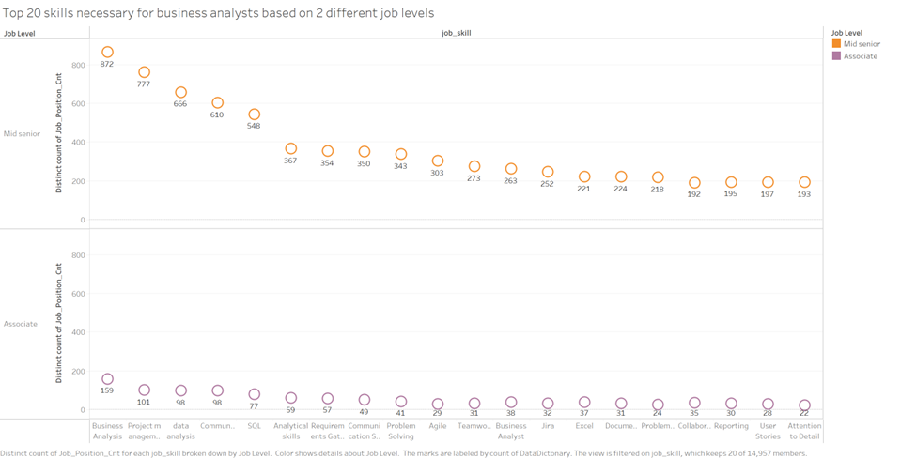This diagram indicates the distribution of the top 20 skills required by business analysts at two different levels: Mid Senior and Associate. The diagram shows that the demand for skills at the senior level is much higher than that at the associate level. The main skill requirements for the senior level are concentrated in the core areas of Business Analysis, Project Management and Data Analysis, and the demand for each skill is significantly higher than that at the associate level. This shows that the requirements for mastering professional skills are higher at the senior level.

### Appendix D.5 | Data Quality Analysis

Data quality analysis is a vital step to validate the data in order to verify that the data visualisation results of this report are accurate and have implementation value.

First, identify and handle missing values in the data to avoid inaccurate effects on the visualisation results. For example, from the MissingValue table compiled by this project below, we can see that there are 9 missing values in the company field, an important field that is often used for analysis, 19 missing values in the job_location field, and the missing value in the job_skill field is as high as 2007.

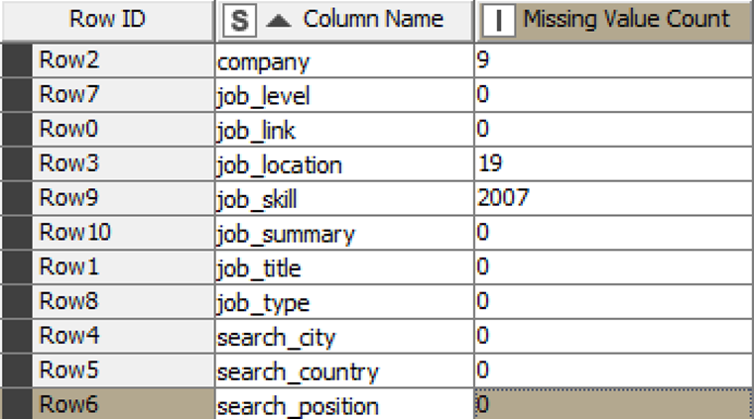

Table: MissingValue

The existence of these missing values may seriously affect the accuracy of data analysis. Therefore, if the correct information cannot be filled in, the report needs to take data filtering measures to deal with these missing data to avoid affecting the credibility of the visual analysis of the data. In our case, we successfully filled in the longitude and latitude of job_location into the Tableau tool manually and successfully displayed the location of the originally missing city in the Map visualisation function.

Furthermore, to prevent trend analysis from losing accuracy due to messy data, removing duplicate data and cleaning up blank entries in key numeric fields are essential tasks in data preparation during the data cleaning process.

Through these data quality control measures, the consistency and accuracy of data mining data results can be ensured, which can maximize the credibility of the visualisation results and provide reliable support for decision-making.

## APPENDIX E | Mrittika Shil , Shimy033

### Appendix E.1 | Bibliography

The CRAAP Test consists of five pillars: currency, relevance, authority, accuracy, and purpose. Currency refers to the timeliness of information, relevance is its relevance to the research, authority assesses the credibility of the author, accuracy is the correctness, reliability, and truthfulness of the source, and purpose helps understand underlying biases in the modern digital age. It is essential for analyzing data sources and understanding digital metrics.

CRAAP Test 1

Data visualisation literacy: Definitions, conceptual frameworks, exercises, and assessments

<https://find.library.unisa.edu.au/discovery/fulldisplay?docid=cdi_crossref_primary_10_1073_pnas_1807180116&context=PC&vid=61USOUTHAUS_INST:UNISA&lang=en&search_scope=MyInst_and_CI&adaptor=Primo%20Central&tab=LIBCOLL&query=any,contains,data%20visualisation&offset=0>

Börner, K., Bueckle, A., & Ginda, M. (2019). Data visualisation literacy: Definitions, conceptual frameworks, exercises, and assessments. *Proceedings of the National Academy of Sciences - PNAS*, *116*(6), 1857–1864. <https://doi.org/10.1073/pnas.1807180116>

|  |  |
| --- | --- |
| CRAAP Test | Evaluation |
| Currency | The article was published in 2019, making it recent and relevant to current discussions on data visualisation literacy. Given the rapid advancements in data visualisation techniques, the publication date ensures that the information is still applicable to modern practices, which is important for your analytic plan on visualising job market data. |
| Relevance | The content is highly relevant to your work as it deals directly with data visualisation literacy, a critical skill for analysing and interpreting large datasets. The article’s focus on teaching and assessing data visualisation aligns well with your need to effectively communicate findings from the LinkedIn job market data you are examining. |
| Authority | The authors—Katy Börner, Andreas Bueckle, and Michael Ginda—are established experts in the field of data visualisation and literacy. The article is published in the Proceedings of the National Academy of Sciences (PNAS), a highly reputable and respected journal. This adds considerable credibility to the source, making it a reliable reference for your analytic plan. |
| Accuracy | The article is based on extensive research and has been validated through its application to over 8,500 students, which underscores its accuracy and reliability. The framework introduced in the paper has undergone revision and validation, ensuring that the methodologies and concepts presented are sound and applicable to real-world scenarios, which is crucial for your project. |
| Purpose | The purpose of the article is to introduce and refine a framework for data visualisation literacy (DVL), with the aim of improving how DVL is taught and assessed. The content is presented objectively and is intended to enhance educational practices in this field. There is no apparent bias, and the information is conveyed in a clear and educational manner, making it suitable for your analytic plan. |

CRAAP Test 2

Tableau prep : up and running : self-service data preparation for better analysis

<https://find.library.unisa.edu.au/discovery/fulldisplay?docid=alma9916475931201831&context=L&vid=61USOUTHAUS_INST:UNISA&lang=en&search_scope=MyInst_and_CI&adaptor=Local%20Search%20Engine&tab=LIBCOLL&query=any,contains,data%20preparation&offset=0>

Allchin, C. (2020). *Tableau prep : up and running : self-service data preparation for better analysis* (First edition.). O’Reilly Media, Incorporated.

|  |  |
| --- | --- |
| CRAAP Test | Evaluation |
| Currency | The document was published as a book in 2020 and accessed through an online library. The information is current and relevant to current practices in data preparation using Tableau Prep. |
| Relevance | The document is directly relevant to self-service data preparation, specifically using Tableau Prep, which aligns with the needs of those looking to clean and organise datasets for better analysis. |
| Authority | The author, Carl Allchin, is affiliated with The Information Lab in London and has a strong background in data preparation and Tableau, making the source credible. |
| Accuracy | The practical lessons and methods presented in the book are based on the author’s extensive experience and have been validated through their application in real-world scenarios. |
| Purpose | The purpose of the book is to guide users in mastering Tableau Prep for efficient data preparation, ensuring that datasets are clean, organised, and ready for analysis. |

### Appendix E.2 | Mind Map

Here is the mind Map of my plan for this project.

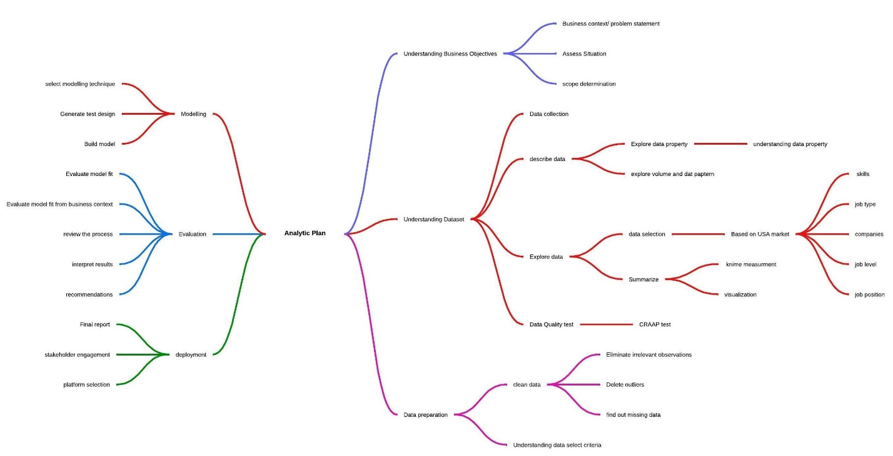

### Appendix E.3 | Data Dictionary

|  |  |
| --- | --- |
| Job Link | |
| Definitions | A job link is mainly a URL sources of specific job which might have a details included in the job post in LinkedIn |
| Justifications | Job link is used to provide the direct link to check the listed requirements for the job |
| Guidelines of Use | For finding the job, it’s a verification link that directs to the job posting. There might be valid time to utilize the link and might have the expiry. |
| Data Type | String (URL) |
| Scope | Each unique URL is unique for each job posting and provides direct source of reference. |
| Source | <https://www.kaggle.com/datasets/asaniczka/1-3m-linkedin-jobs-and-skills-2024> |

|  |  |
| --- | --- |
| Job Summary | |
| Definitions | Job description refers to job description containing key roles and responsibilities and key indicators of job. |
| Justifications | It provides required details about the core tasks and core skills needed to perform the job, effective for assessing the requirements of the job |
| Guidelines of Use | Ensure the summary is a concise reflection of the full job description. It should cover the main aspects of the role without extraneous details. |
| Data Type | String (Long Text) |
| Scope | Combined source of roles, responsibilities, eligibility and criterias |
| Source | <https://www.kaggle.com/datasets/asaniczka/1-3m-linkedin-jobs-and-skills-2024> |

|  |  |
| --- | --- |
| Job Title | |
| Definitions | The advertised job position for hiring talented people. |
| Justifications | With job title job seeker can categorise and classify the job roles |
| Guidelines of Use | Use the exact job title as provided by the employer to ensure accuracy and consistency. Standardize common roles to avoid duplicates with different naming conventions.  Job title determines the accuracy and consistency and also standardize common grounds to perform specific roles and responsibilities. |
| Data Type | String |
| Scope | Specific to each job listing. |
| Source | <https://www.kaggle.com/datasets/asaniczka/1-3m-linkedin-jobs-and-skills-2024> |

|  |  |
| --- | --- |
| company | |
| Definitions | The name of the company that is hiring for the job position. |
| Justifications | Identifies the employer, which is essential for company-specific analysis and understanding industry trends. Also, allowing job seekers to search for opportunities by company name. |
| Guidelines of Use | Ensure the company name is recorded accurately and consistently. Avoid abbreviations unless commonly recognized. |
| Data Type | String (Text) |
| Scope | Unique to each job listing, representing the hiring company. |
| Source | <https://www.kaggle.com/datasets/asaniczka/1-3m-linkedin-jobs-and-skills-2024> |

|  |  |
| --- | --- |
| Job location | |
| Definitions | the physical location of the job including city and state |
| Justifications | Indicates where the geographical location is helps to sort jobs based on preferable city and state |
| Guidelines of Use | Need to ensure the correct city and state |
| Data Type | Standardized geographic location address followed by a standard format |
| Scope | Location based job posting |
| Source | <https://www.kaggle.com/datasets/asaniczka/1-3m-linkedin-jobs-and-skills-2024> |

|  |  |
| --- | --- |
| Job city | |
| Definitions | City based focus on searching and finding job |
| Justifications | Used for filtering and analysing job opportunity based on preferable city to understand local job market |
| Guidelines of Use | Ensure city name is correct. If the job is virtual/ offsite, it should indicate specifically. |
| Data Type | String (Text) |
| Scope | Specific to city based job listing. |
| Source | <https://www.kaggle.com/datasets/asaniczka/1-3m-linkedin-jobs-and-skills-2024> |

|  |  |
| --- | --- |
| Job country | |
| Definitions | The geographic location based on country where job seekers concentrated on specific locations. |
| Justifications | Understanding country based/ region-based job listings and analysis job opportunity based on countries. |
| Guidelines of Use | Ensure country is correctly mentioned. Use full name, not any code word/ abbreviations |
| Data Type | String (Text) - though standardization may be applied. |
| Scope | Specific to each job listing. |
| Source | <https://www.kaggle.com/datasets/asaniczka/1-3m-linkedin-jobs-and-skills-2024> |

|  |  |
| --- | --- |
| Job position | |
| Definitions | General Designation/ category of job which is aligned with job title. |
| Justifications | Helps to classify the job into various roles and gives essential insight about type of job. |
| Guidelines of Use | The job position should be clearly defined and consistent in terms of task and skills |
| Data Type | String (Text) |
| Scope | Broad categorisation of the job role. |
| Source | <https://www.kaggle.com/datasets/asaniczka/1-3m-linkedin-jobs-and-skills-2024> |

|  |  |
| --- | --- |
| Job level | |
| Definitions | Categorization of job level which means entry level to top senior level |
| Justifications | Identifies the experience and skill level for each individual job level. High/ seniority demands more skills and experience |
| Guidelines of Use | Job level should be mentioned correctly based on year of experience and skills required |
| Data Type | Entry level to top senior level |
| Scope | Specify the seniority |
| Source | <https://www.kaggle.com/datasets/asaniczka/1-3m-linkedin-jobs-and-skills-2024> |

|  |  |
| --- | --- |
| Job type | |
| Definitions | The nature of the job in terms of work arrangement (e.g., Onsite, Remote).  It defines the type or mode of the job whether in physical location presence or online presence is required or not! |
| Justifications | Indicates nature of job which is crucial for job seekers preferences. |
| Guidelines of Use | Recording job type is important whether physical or online presence is expected. If hybrid, employer should specify the proportion of job mode. |
| Data Type | Picklist (Hybrid, Onsite, Remote) |
| Scope | Specific to each job listing. |
| Source | <https://www.kaggle.com/datasets/asaniczka/1-3m-linkedin-jobs-and-skills-2024> |

|  |  |
| --- | --- |
| Job Skill | |
| Definitions | The skills required to perform the job in an working environment (Hard or soft skills) |
| Justifications | Indicates candidates’ capability to test, design and implement the task responsible for. |
| Guidelines of Use | Record the job skills carefully based on employer’s demand; more industry oriented to match with the market trend. |
| Data Type | Picklist (leadership, communication, business analysis, negotiation) |
| Scope | Specific to each job listing. |
| Source | <https://www.kaggle.com/datasets/asaniczka/1-3m-linkedin-jobs-and-skills-2024> |

### Appendix E.4 | Summary of Data Exploration

Data Exploration is process and goes with systematic approach. I followed each of the steps to make this project better understandable for getting the highest possible outcome.

Data Acquisition: For data acquisition from open source, I used Kaggle.com and downloaded the large dataset to understand and check the overall attributes of the data such as number of variables, types of variables, volumes and consistency of the open-source data.

Data preparation is one of the best parts of this assignment because it takes different phases to filtrations and preparation for further use which is modelling evaluation, deployment and visualisation. The steps are explained in the following section.

* Data Cleaning: The next step is data cleaning which is a major part of data preparation. Among three different data set had job links which has used to combine all together. KNIME is the common tool I used for overall data cleaning process. The steps I followed following options to prepare a clean dataset for analysis.

1. Integrating dataset altogether: For integrating data, I used job link as a common focal point to merge all the dataset together and the major outcome is the filtered data.
2. Removing unnecessary columns: After then, I removed four unnecessary columns which has no use in analysis at any point after analysing the data category and types and meaning of the data which were strings and unreasonable for use to draw a conclusion.
3. Redefining column names: I have renamed the columns based on the analysis scope to make it more specific and the output table was used for developing data dictionary.
4. Data filtration: For filtration, I focused on the scope of the project which was country focused and different metrics were used to get the desired outcome.
5. The first step I followed was keeping the basis of country (USA) and the job role/job title was Business Analyst, and the limitations of that variable was differences in capitalization and needed to manipulate for correcting and replacing the value.
6. The Job Skills variable in filtered data was split into columns using KNIME, which resulted in accurate analysis but led to repetition. To improve accuracy, skills with similar values were renamed to string names, such as business analytic to Business Analysis Skills. Excel was extracted to generate visuals, maintaining correlation among variables.

Data understanding

I tried to understand the data, based on scope of our project. This analysis focuses on LinkedIn job postings from the United States, specifically for Business Analyst roles. The key columns I derived from filtration includes Job Title, Job Skills, Job Type, Country, and Job Links. Country is the initial focal, Job Title refers the data to Business Analyst roles, Job Links acts as a combined metric, and Job Skills analyses the required skills for different job positions. These columns help refine the dataset and create desired analytical metrics and co-relations.

Result Analysis (After data cleaning)

This section involves KNIME applications and using different KNIME nodes to filter and clear data for analysis. Here is the KNIME workflow and explanations why I have used these nodes. I will explain step by step to go with the overall procedure of explanation.

1. I uploaded three datasets together and used Job posting data set and used column filter to *reduce the unnecessary/ redundant columns* to get rid of four different columns ( last_proccessed time and other two columns).
2. Second i have used string date and time node to make the *correct format* of time for variable “first seen” and tried to findout whether this variable is useful.
3. Now I have all three-dataset ready for *integration* and used Joiner Node to combine them and creating one dataset for analysis
4. After that I used rule-based filter node to *filter the dataset specific* such as using country- united states data is our main concern as per project justification.
5. The next step is row filter for applying some criteria to filter the data more. For rule-based data I filtered job skills (added conditions) and added job title criteria for filtrations to avoid any missing value or outliers.
6. Then I used next step is cell splitter node, group by and unpivoting node to *capture all the missing value.*
7. I used column rename node to make the *column heading specification* to understand better
8. Then I used column filter node again delete *unnecessary column* (First_seen variable)
9. And used column resorter to organize the column
10. Finally added excel writer to *save filter dataset* in my device and finally done with the data cleaning.

Here is the KNIME Workflow evidence from my analysis.

Figure-1: KNIME Workflow

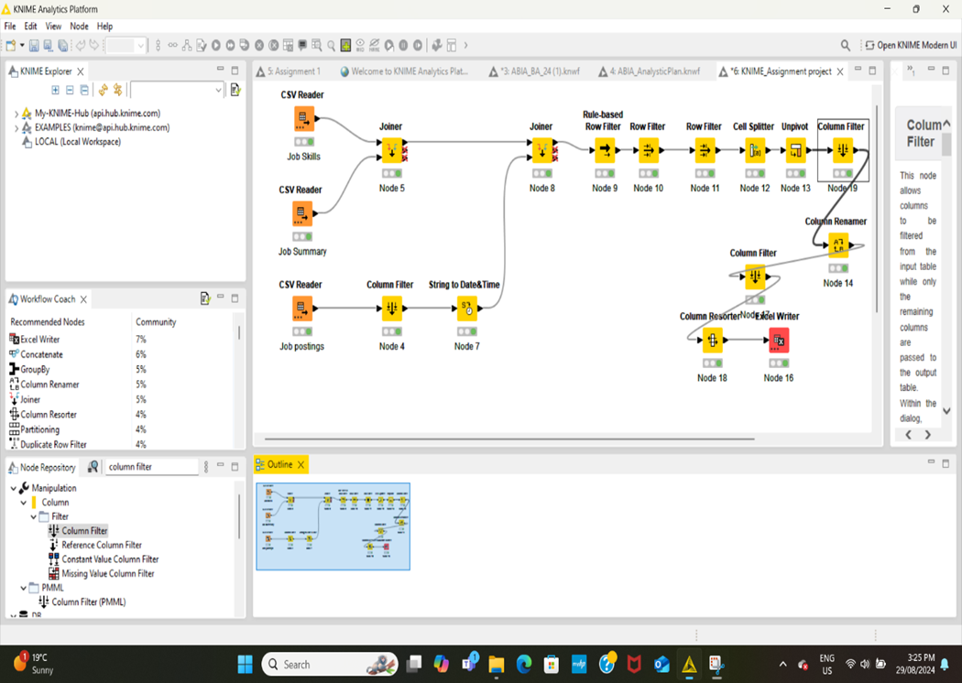

Here is the filtered data output after applying KNIME workflow procedure:

Figure-2: Filtered output table

|  |
| --- |
| Initial Extraction based on analysis scope |
|  |
| Final filter conversion data with job skills |
|  |

Data Visualisation

After data extraction and filtration, I approached to data visualisation keeping in mind the analysis scope of our project. Here are some snippets from the visualisation to generate general understanding from the overall data point.

Figure-3: Business Analyst Job hotspot

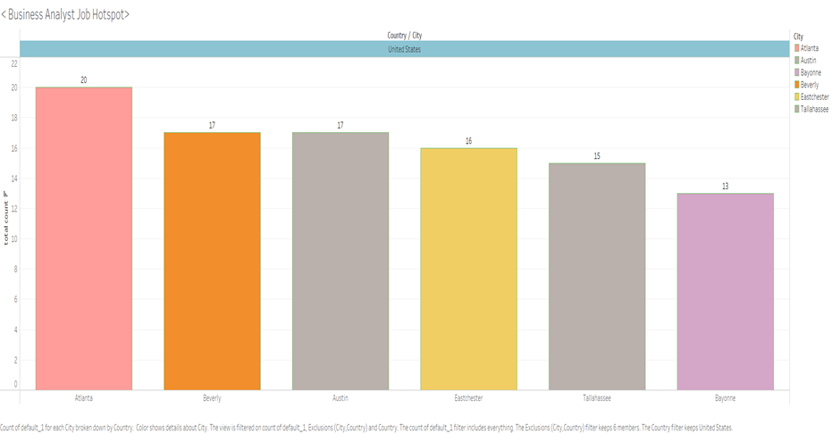

Figure 3 determines that the major cities for the business job hotspot and the number of counts of the job count based on those cities of USA which are Atlanta, Beverly, Austin and other two cities. These cities are the job spot for Business analyst job and more popular among the job seekers.

Figure-4: Top Ten Skills

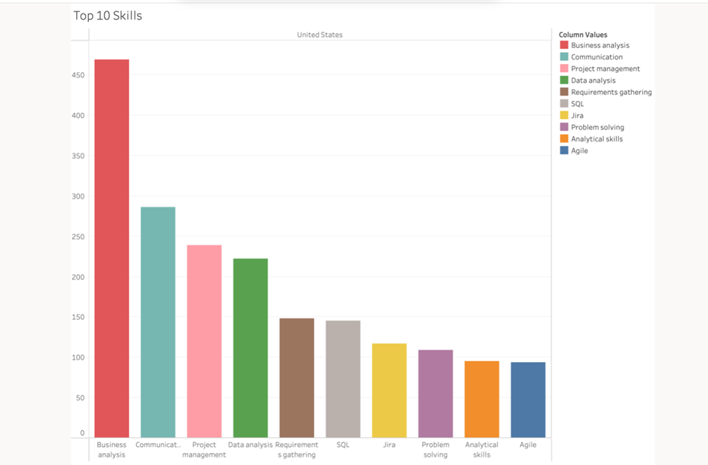

This figure-4 determines that the most important skills is searched by the employers which are business analysis, communication skills, project management skills, data analysis, requirement gathering, SQL, Jira, problem solving, analytical skills and agile methodologies. A job seeker who is applying for the business analyst role should have these skills to compete over USA market.

Figure-5: Job level based on city

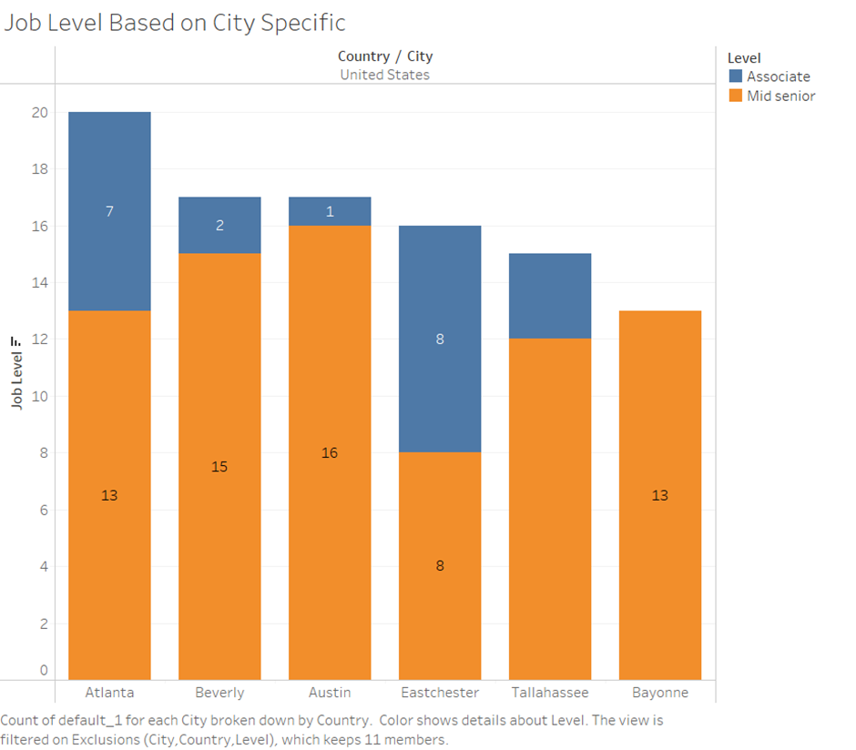

This figure 5 represents that based on major cities; job level varies. I found that top five cities offer more senior levels rather than associate positions. It is more decisive for the job seekers who are trying to change their first job and want more comprehensive job will be applicable. We can see associate positions is high at Eastchester city and other cities lag.

Figure-6: Top Position

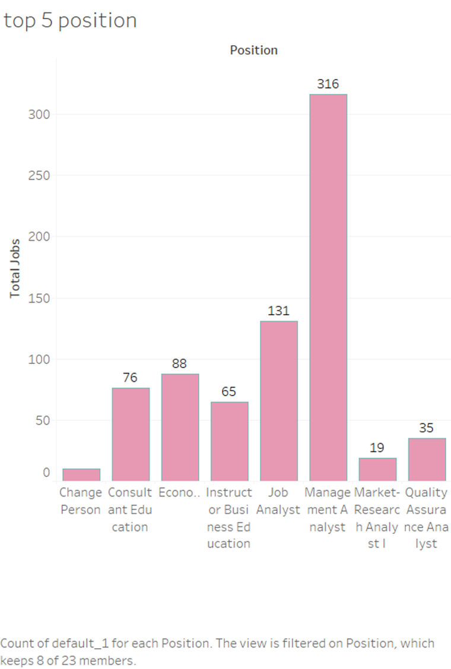

Figure- 6 represents that companies post their jobs other than business analysts name where management analyst is popular job post and gets the higher number of job position in USA market.

Figure-7: Top five companies in USA market

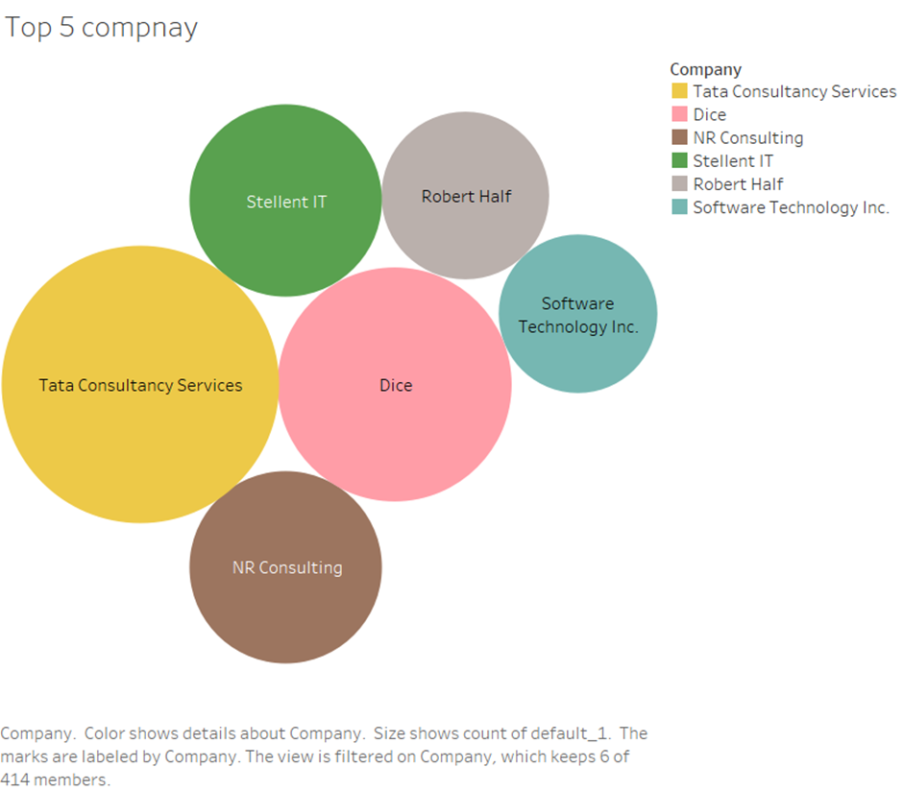

This figure-7 represents the top five companies having maximum job posting in the USA city covering large portion of market share.

Figure-8: City and Job position

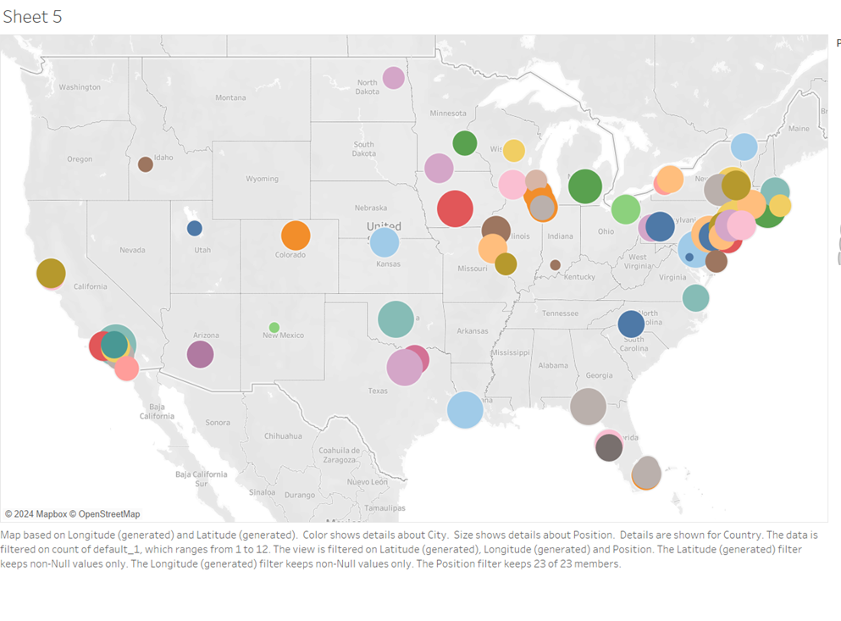This figure shows that positions are available based the city. These focuses highlighting of cities which has the majority job positions.

### Appendix E.5 | Data Quality Analysis

For data quality analysis, there are couples of methods are followed by the analysts. I have followed two methods.

Volume check (After Filtering)

After filtering following above steps explained, I derived 756 rows and 11 columns for overall analysis. The volume has reduced significantly after filtrations which represents that I derived quality having no issues with data set. Majority columns are strings not numerical. This data set are followed by Crapp test which is shown above with bibliographic analysis.

Outlier test: I checked the overall data, and all the data are string, not numerical, that's why I did not find any outlier for the dataset.

Missing Value

For this project, I have filtered all the data above you can see the KNIME workflow and used column filter, unpivot node for finding the missing value in column format. In total 44 data were missing from 3 data sets. Here are the observations of three dataset.

Figure-10: Missing Values

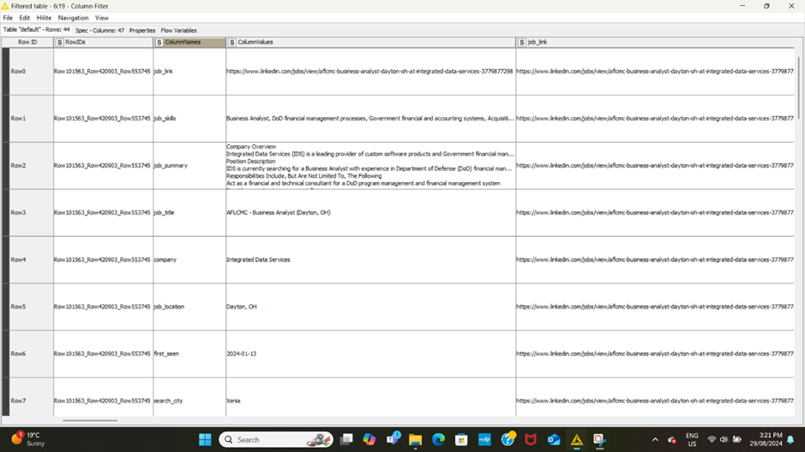

Overall, the data's completeness and consistency are hindered by high missing values in the Job Skills variable, and low accuracy due to repeated values. However, relatives' values can be analyzed for data accuracy. For validity of the more test can be included such as multicollinearity test.

## APPENDIX F | Trung Hieu Huynh

### Appendix F.1 | Bibliography

Harris, A., & Clark, C. (2024). Understanding the Diffusion of Business Analysis Responsibilities. *The Journal of Computer Information Systems*, *ahead-of-print*(ahead-of-print), 1–11. <https://doi.org/10.1080/08874417.2023.2193964>

|  |  |
| --- | --- |
| Currency | The article was published on April 12th, 2023, and stayed original until now. The current information helps to understand the responsibilities of Business Analysis staff across industries. |
| Relevance | The paper discussed the changing condition of business analysis and how organizations are adopting it for their projects. It is high relevant to your analytic plan |
| Authority | Amy Harris and Carol Clark are the co-authors of the article which was published by Taylor & Francis publisher. Both authors are from Middle Tennessee State University, USA. |
| Accuracy | This article was found from the UniSA’s Library and was peer-reviewed. The paper was presented in a professional tone, well-formatted, and no grammar or spelling errors. |
| Purpose | The article aims to answer the required skills, the most popular job title linked with business analysis job and identify the nuances in skill requirements depending on the specific business analysis role or job title. |

Akinoso, O. A. P. H. E. A. C. D. O. A. E. (2024). THE STRATEGIC VALUE OF BUSINESS ANALYSTS IN ENHANCING ORGANIZATIONAL EFFICIENCY AND OPERATIONS. International Journal of Management & Entrepreneurship Research, 6. https://doi.org/https://doi.org/10.51594/ijmer.v6i4.1059

|  |  |
| --- | --- |
| Currency | The article was published in April 2024 in the International Journal of Management & Entrepreneurship Research. Since it was released recently, the paper's content is considered timely and relevant information to the topic of our study. The link is functioning and open for public access. |
| Relevance | The article discussed about the skills, roles, and responsibilities of business analysts in enhancing companies’ innovation and transformation which is insightful for our study. |
| Authority | The authority of the document is strong based on the credentials of the authors and the reputation of the journal. The article was written by Oladapo Adeboye Popoola, Henry Ejiga Adama, Chukwuekem David Okeke, and Abiodun Emmanuel Akinoso. Their links with groups in the UK, USA, and Nigeria show that they have a broad and global view of the subject. |
| Accuracy | The information is supported by evidence, including references to other studies and case studies, which enhances the article’s credit. The language is professional and objective, with no evident bias or emotional language. The article is written in a formal academic style for a research publication. |
| Purpose | The purpose of this post is to inform and share with readers the significant role that business analysts play in improving company operations and innovation. It also offers insights and practical applications based on extensive analysis. |

### Appendix F.2 | Mindmap

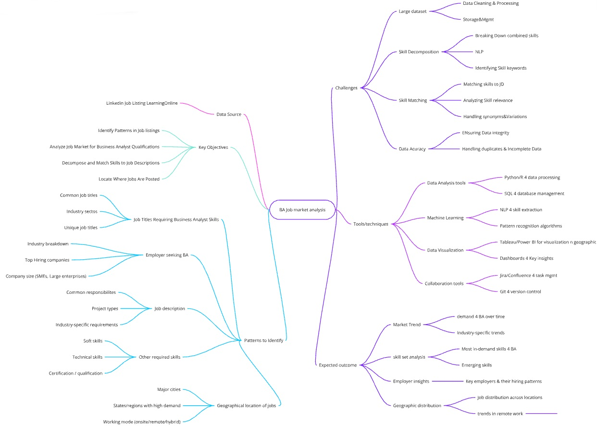

### Appendix F.3 | Data Dictionary

|  |  |
| --- | --- |
| Job_link | |
| Definitions | A direct connection to a hiring job posting on LinkedIn platform. |
| Justifications | gives direct access to the job listing for additional information and confirmation. |
| Guidelines of Use | Frequently check the link to ensure it is active and not expired. |
| Format | String - hyperlink |
| Source | The author made the dataset available to the public after conducting a navigable search and extracting data from the LinkedIn site.  <https://www.kaggle.com/datasets/asaniczka/1-3m-linkedin-jobs-and-skills-2024> |

|  |  |
| --- | --- |
| Job_summary | |
| Definitions | Responsibilities, missions, and requirements for the hiring role. |
| Justifications | Provides a summary of the job's main responsibilities and required skills, which is valuable for analyzing the role's requirements. |
| Guidelines of Use | Make sure the summary is a brief and accurate representation of the entire job description, highlighting the crucial components and omitting unnecessary details. |
| Format | String |
| Source | <https://www.kaggle.com/datasets/asaniczka/1-3m-linkedin-jobs-and-skills-2024> |

|  |  |
| --- | --- |
| Job_title | |
| Definitions | The name of the advertised hiring position. |
| Justifications | Pointing the job that is advertised, which is critical for analysis categorization and categorisation, as well as job searchers seeking certain titles. |
| Guidelines of Use | Use an exact job title created by the company for accuracy and consistency. |
| Format | String |
| Source | <https://www.kaggle.com/datasets/asaniczka/1-3m-linkedin-jobs-and-skills-2024> |

|  |  |
| --- | --- |
| Search_city | |
| Definitions | The cities are given by the dataset’s author to search and download the data. |
| Justifications | Used to select and analyze employment prospects by city, presenting information on local job markets. |
| Guidelines of Use | Maintain the city information correctly |
| Format | String |
| Source | <https://www.kaggle.com/datasets/asaniczka/1-3m-linkedin-jobs-and-skills-2024> |

|  |  |
| --- | --- |
| Job_level | |
| Definitions | The ranking of the job hiring |
| Justifications | Establishes the range of experience requested, which is critical for both applicants and market segmentation. |
| Guidelines of Use | As given by employers, set it as the standard terms such as Junior, Senior and so on. |
| Format | String |
| Source | <https://www.kaggle.com/datasets/asaniczka/1-3m-linkedin-jobs-and-skills-2024> |

|  |  |
| --- | --- |
| Job_location | |
| Definitions | The job's actual location includes the city and state. |
| Justifications | Describes the job's location, which is useful for geographical analysis and analyzing the distribution of occupation chances. Furthermore, it allows job candidates to select offers based on their geographic region. |
| Guidelines of Use | Format the list of cities and states as global recognition. |
| Format | String |
| Source | <https://www.kaggle.com/datasets/asaniczka/1-3m-linkedin-jobs-and-skills-2024> |

|  |  |
| --- | --- |
| Search_country | |
| Definitions | The nation where the job is situated or where the employment hunt is concentrated. |
| Justifications | Useful for geographic location examination and comprehension of how employment opportunities are distributed across countries. |
| Guidelines of Use | Assure that the nation is accurately logged. Avoid acronyms and instead use the country's legitimate name. |
| Format | String |
| Source | <https://www.kaggle.com/datasets/asaniczka/1-3m-linkedin-jobs-and-skills-2024> |

|  |  |
| --- | --- |
| Search_position | |
| Definitions | The generic rank or division of the employment is often the same as the job title. |
| Justifications | Allows to categorisation of job positions into the groups of roles or functions for analysis. |
| Guidelines of Use | Check the role is well-defined and fits the job title. Use similar wording throughout all applications. |
| Format | String |
| Source | <https://www.kaggle.com/datasets/asaniczka/1-3m-linkedin-jobs-and-skills-2024> |

|  |  |
| --- | --- |
| Company | |
| Definitions | The name of the company that is hiring for the job position. |
| Justifications | Recognizes the employer, which is critical for doing company-specific analyses and identifying industry trends. Also, job hunters may follow company names for an opportunity. |
| Guidelines of Use | Make sure the company name is written fully and correctly. |
| Format | String |
| Source | <https://www.kaggle.com/datasets/asaniczka/1-3m-linkedin-jobs-and-skills-2024> |

|  |  |
| --- | --- |
| Job_type | |
| Definitions | The working arrangement between inside office or outside. |
| Justifications | Describes the work setting which is extremely important for applicants with certain preferences or interests. |
| Guidelines of Use | Document the job type precisely as indicated by the employer. |
| Format | String |
| Source | <https://www.kaggle.com/datasets/asaniczka/1-3m-linkedin-jobs-and-skills-2024> |

### Appendix F.4 | Data exploration

I have reviewed the three datasets downloaded from the website Kaggle.com and performed Data Cleaning to remove unnecessary columns from the dataset “Linkedin_Job_Postings.csv”. Also, from “Job_posting” dataset, I have applied filter on “Job_title” column to show only the value “Business*”, I aims to simplify the data to focus on Business Analysis job title. After that, all datasets were merged into one dataset by KNIME application with “Job_link” as the primary key for table relationship. The detail of the workflow as per Figure 1 below:

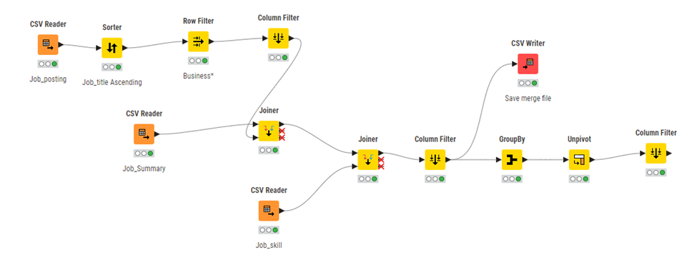

*Figure 1 Data preparation in KNIME*

On the first trying to use the merged dataset in Tableau, I found that there are many Null values in the dataset, therefore, I used the GroupBy and Unpivot node to address those missing values.

And the prepared data was exported from KNIME again to continue work in Tableau application for visualisation. In Tableau application, I drag the job title, company and country into Sheet to see which company hire the most positions in the United States. The Figure 2 below shows the top 5 companies in the United States hiring Business Analysts.

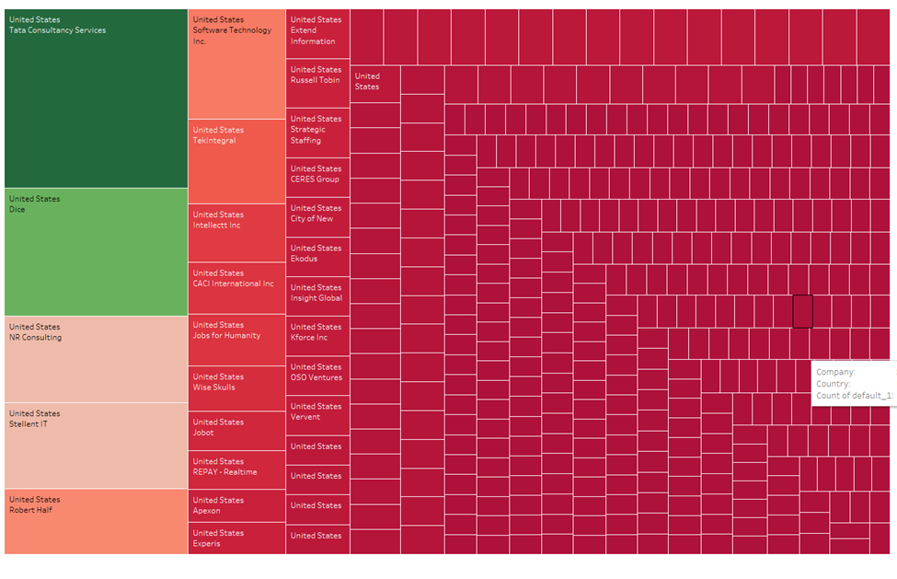

*Figure 2 Top five companies hiring Business Analysis*

The next goal is finding the top 5 cities in the United States hiring business analysts. This time, I removed the Country variable, then I dragged the City variable to the Sheet and changed the Symbol Maps to know which city required the most business analysts' people: Atlanta (20), Beverly and Austin (17), Eastchester (16), and Tallahassee (15)

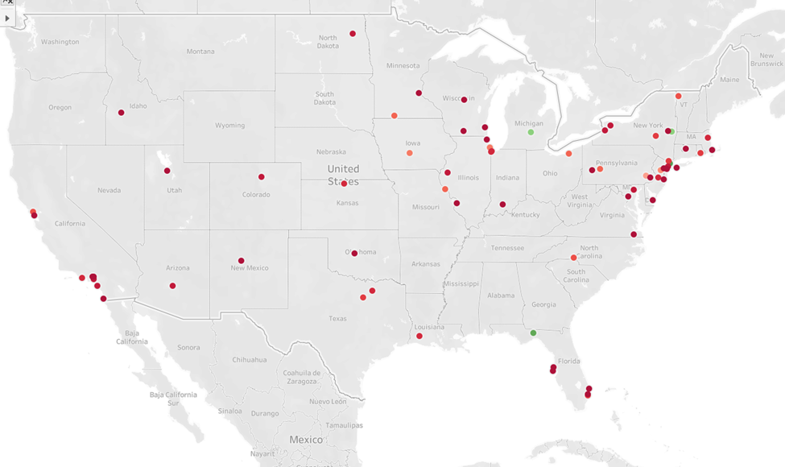

*Figure 3 Top five cities hiring Business Analyst*

However, there are 172 unknown cities so the current outcome is not correct, as per Figure 4. And there was no States details to match with these cities. The Location variable is needed for this time but I have to convert it to full name of the states in the United State, from “Location” to “State” in Figure 5.

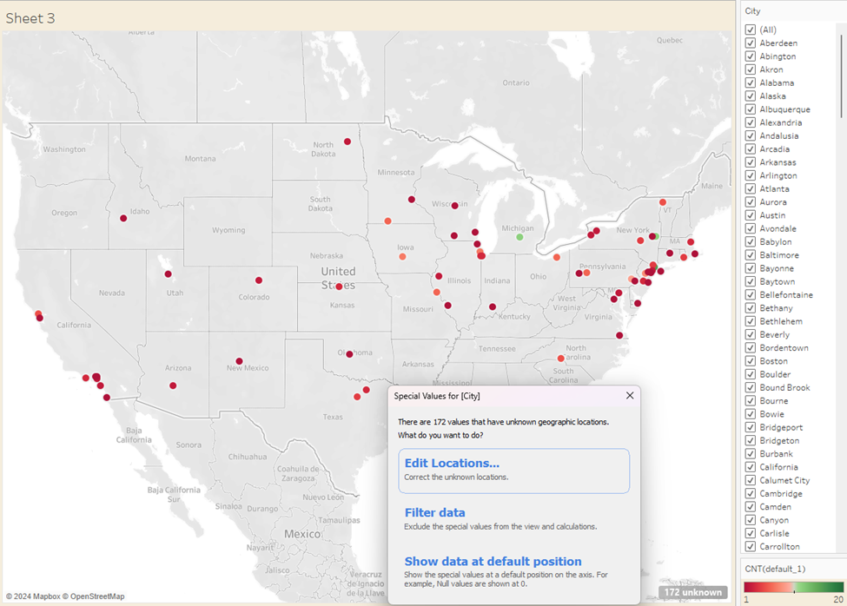

*Figure 4 172 Unknown cities*

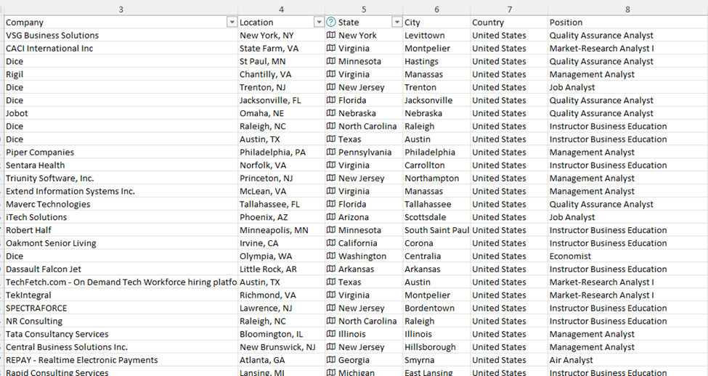

*Figure 5 Abbreviation name to full name of the States*

### Appendix F.5 | Data analysis

Since the information on the states is missing a small amount in the dataset, I think the dataset is slightly incomplete, therefore the outcome of the study might not be correct for geographical opportunities trending.